Orinja’s Stove With Lutfiyah’s Improvement
ETHOS/Aprovecho Stove Camp August 2005

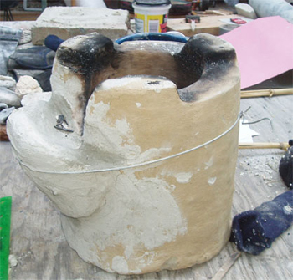
Orinja’s Bangladesh Mud Stove
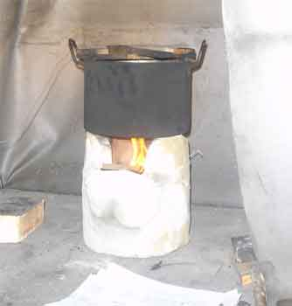
Testing Orinja’s Bangladesh Mud Stove in the Hood
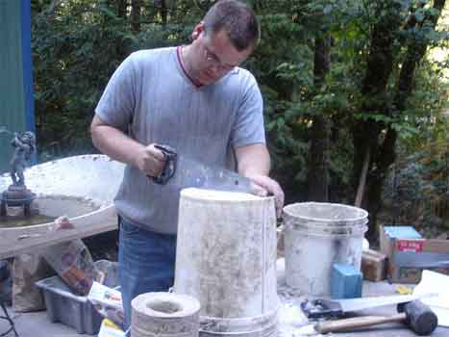
Steve Cutting Mold for Monolithic Version of Orinja’s Stove
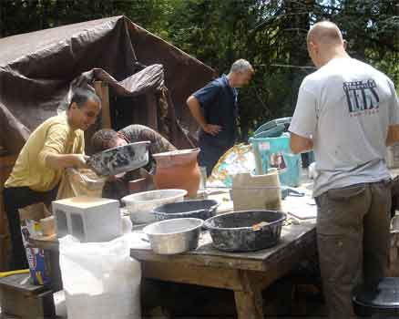
Ethustiastic Participants preparing Clay
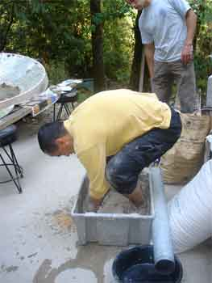
Mouhsine the Master Mixer
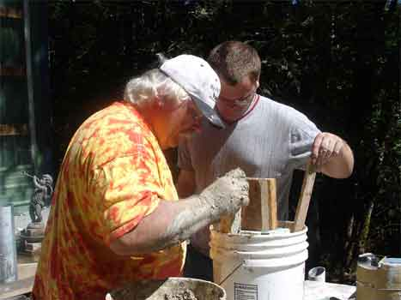
Dean and Steve Packing the Mold
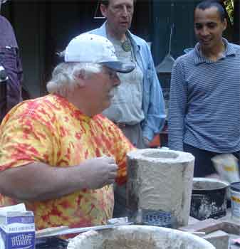
Dean Appling the Finishing Touches. Note Grate
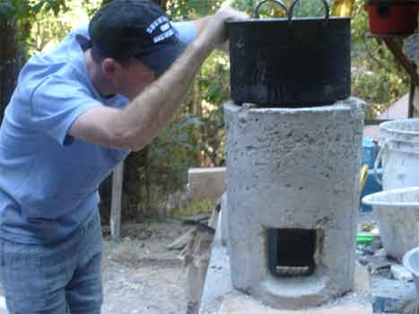
Mike Checking the Gap
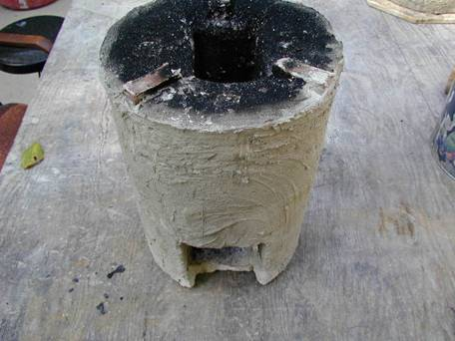
Orinja’s Improved Stove After testing

Lutifiyah’s Improved Orinja Stoves Takes Less Time to Boil
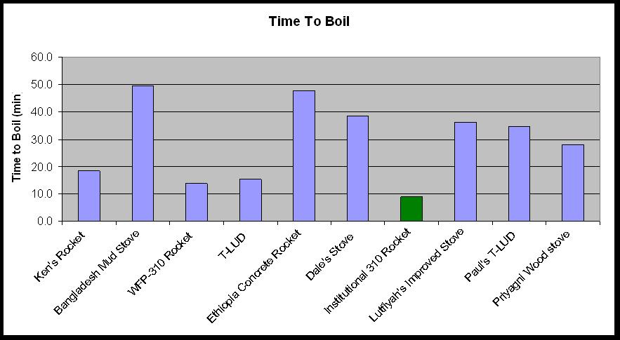
It Uses Less Fuel to Boil and slightly More to Simmer
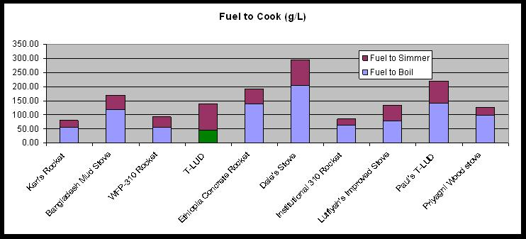

CO Emissions are Lower for Boiling and Simmering
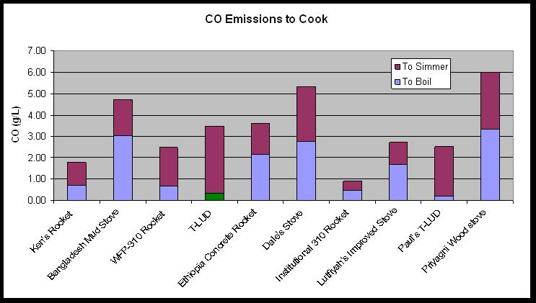
CO to Cook is Improved. CO2 is About the Same.
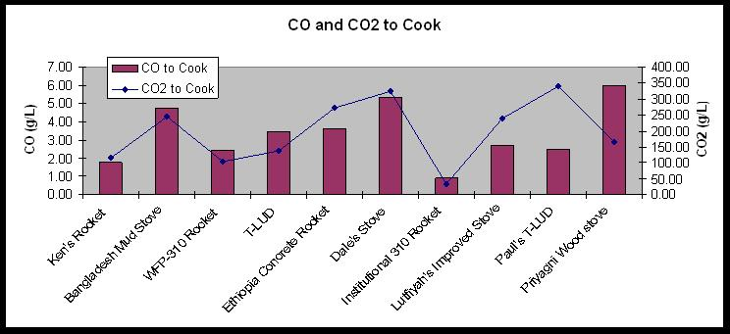

Particulate Matter is Higher for Boiling and Simmering
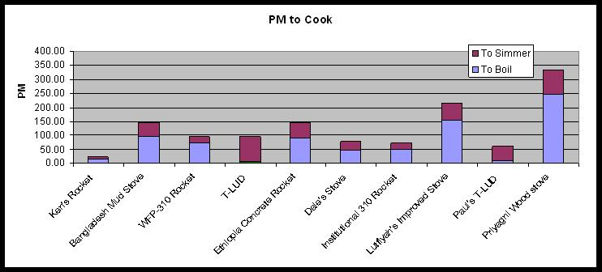

CONCLUSIONS:

