PHOTOS OF EQUIPMENT AND STOVES
APROVECHO’S SUMMER STOVES CAMP, 2005
Dean Still and Nordica MacCarty

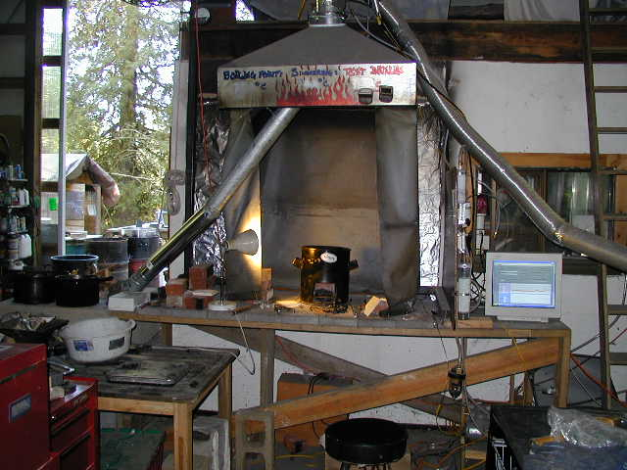
Emission Collection Hood

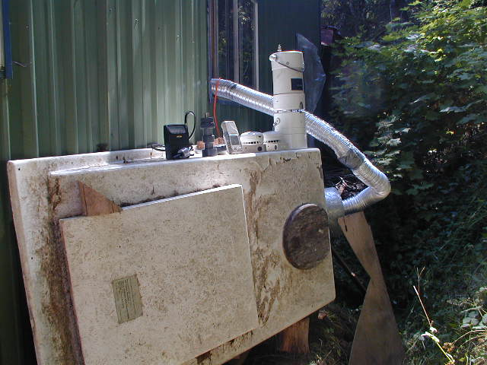
Emissions Collection Chamber

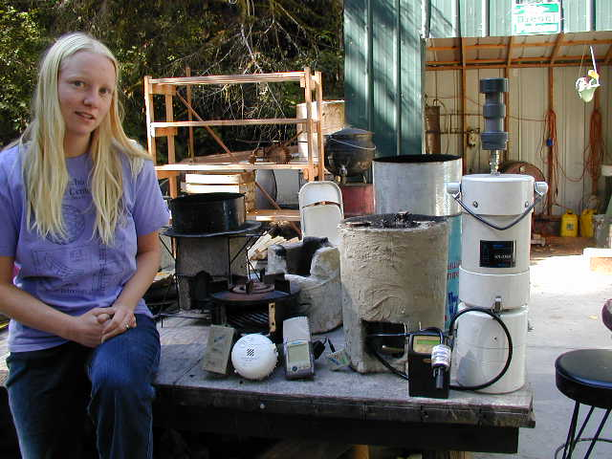
Portable Emissions Monitors

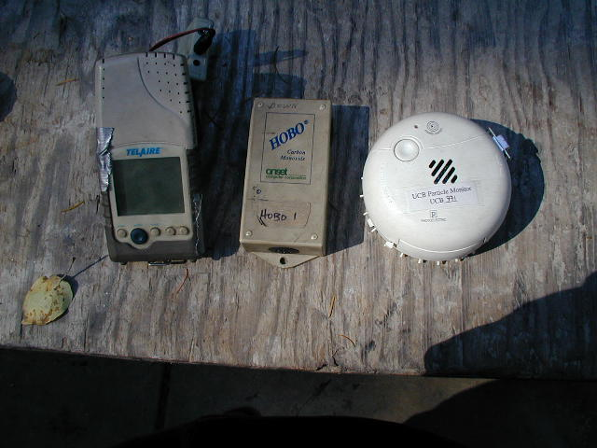
Portable CO2 Meter with HOBO Data Logger, HOBO CO Logger, UCB Datalogging Particulate Meter

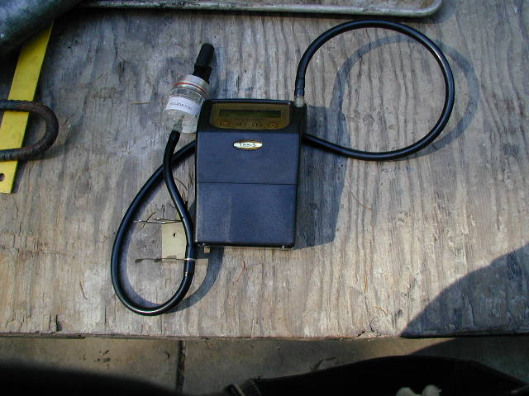
Buck Pump and Filter Particulate Meter

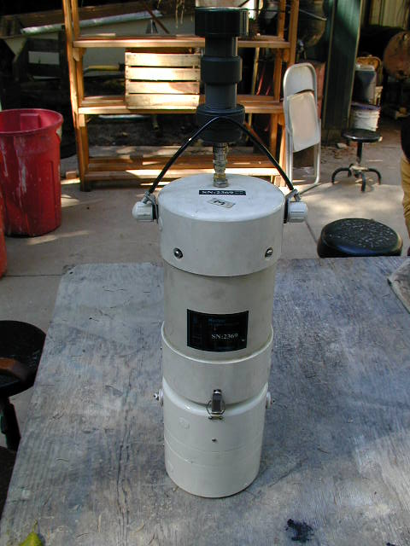
Minivol Particulate Pump & Filter System
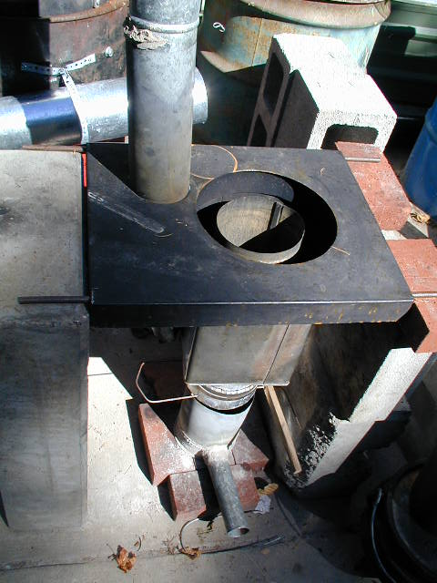
Paul Anderson’s T-LUD

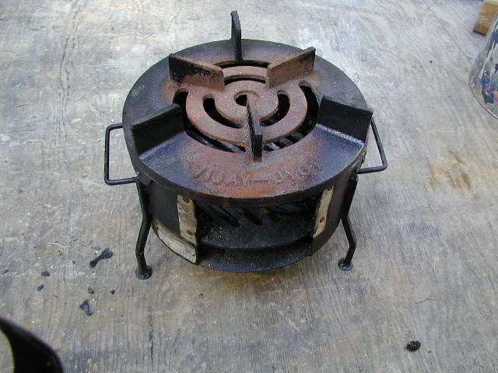
Priyagni Wood Stove

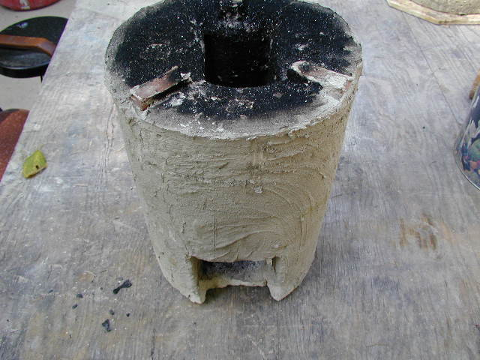
Lutfiyah’s Improved Stove Built at Camp based on Rocket Principles

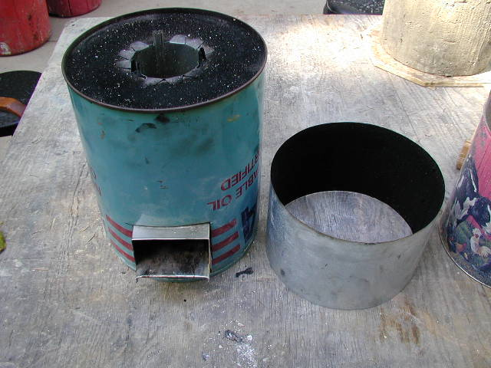
WFP-310 Rocket with 310 Stainless Steel combustion chamber and skirt

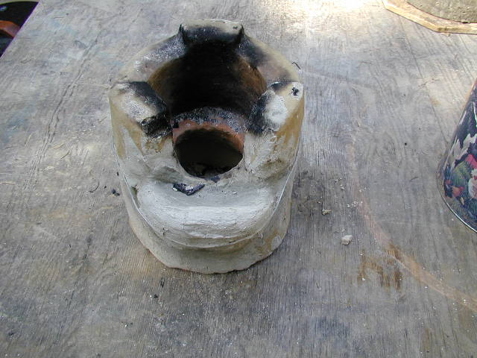
Lutfiyah’s Bangladesh Mud Stove

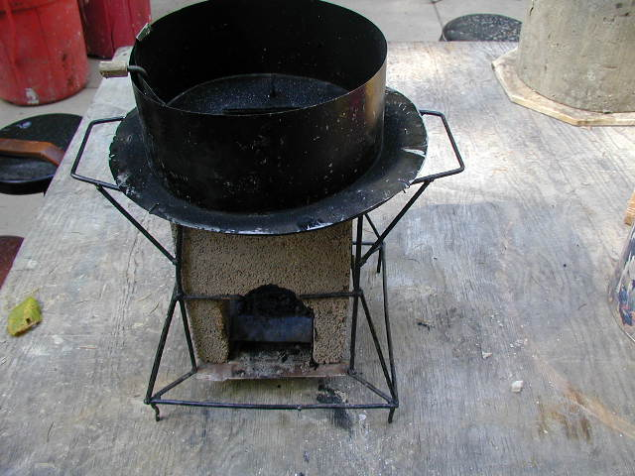
Ethiopia Concrete Rocket

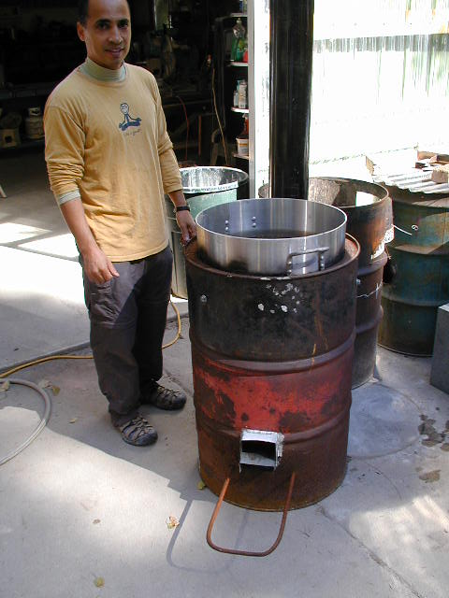
Institutional Rocket Stove with 310 Stainless Rocket Elbow

