Una estrategia de la lucha contra la
CAPIATA – ASUNCIÓN – República DEL PARAGUAY - - FORMOSA – República DE ARGENTINA – COCHABAMBA BOLIVIA
pobreza y protección de medio ambiente

EDUCACIÓN ALTERNATIVA – ENERGÍA RENOVABLE – JUSTICIA SOCIAL

Lasting Impacts of a Solar Cooker Project in Bolivia
By Melanie Szulczewski, Ph. D.
Solar Household Energy, Inc.
April 2006
Photos and editing by David Whitfield – Director - CEDESOL Foundation

Under the auspices of the French NGO Bolivia Inti, alternative energy experts David and Ruth Whitfield introduced solar cooking to many villages in Bolivia between 2000 and 2003. After demonstrating solar cookers in public forums, they then trained those people expressing interest in how to make and use solar cookers.

Research was conducted in the central highlands of Bolivia in 2005 to assess the continuing impacts of solar cooking on participants of these solar cooking courses conducted by the Whitfields. The researcher, Chris Pell of the University College London, interviewed 170 people with and without solar cookers to determine whether their use affected household fuel consumption.

The data showed that 92.7% of the solar cooking course participants continue to use their solar cooker three to five years after the course ended. In fact, 62.4% of all participants use their solar cooker at least once a day during the dry season, demonstrating a lifestyle change that incorporates solar cooking into their daily lives. The solar cooker now supplements their other energy sources: gas, wood, or a combination of gas and wood.

Solar cooking provides numerous advantages, including health, environmental, and economic benefits. For families in developing countries, the strongest of these may be the economic benefit of buying less fuel for their other cooking methods. Pell found that there was a significant difference (at the 95% confidence level) of the monthly fuel expenditure per household member between families with a solar cooker and those without one for those households that purchase but do not forage for their fuel wood. Households with solar cookers spent an average of $5.95 per household per month in the dry season and $6.70 in the wet season, while households without solar cookers spent an average of $9.94 in the dry season and $10.39 in the wet season. This demonstrates a savings of $3.99 per month in the dry season and $3.69 in the wet season. These families reduced their fuel expenses by 40.1% and 35.5% in the dry and wet seasons, respectively.

Further analysis of the data reveals that the more the solar cooker is used, the lower the monthly fuel expenditure per household. This confirms with statistically significant results the direct link between using solar cookers and reducing fuel expenses.

Although both the seasonal and daily frequency of solar cooker use varied greatly among households, it is clear that its advantages have caused over 95% of participants to continue to use their solar cookers years after their initial training. This resounding acceptance of solar energy as an alternative fuel provides numerous benefits, including statistically significant savings in fuel expenditure, a reduction in the inhalation of toxic smoke and of the environmental degradation due to the consumption of fuel wood.

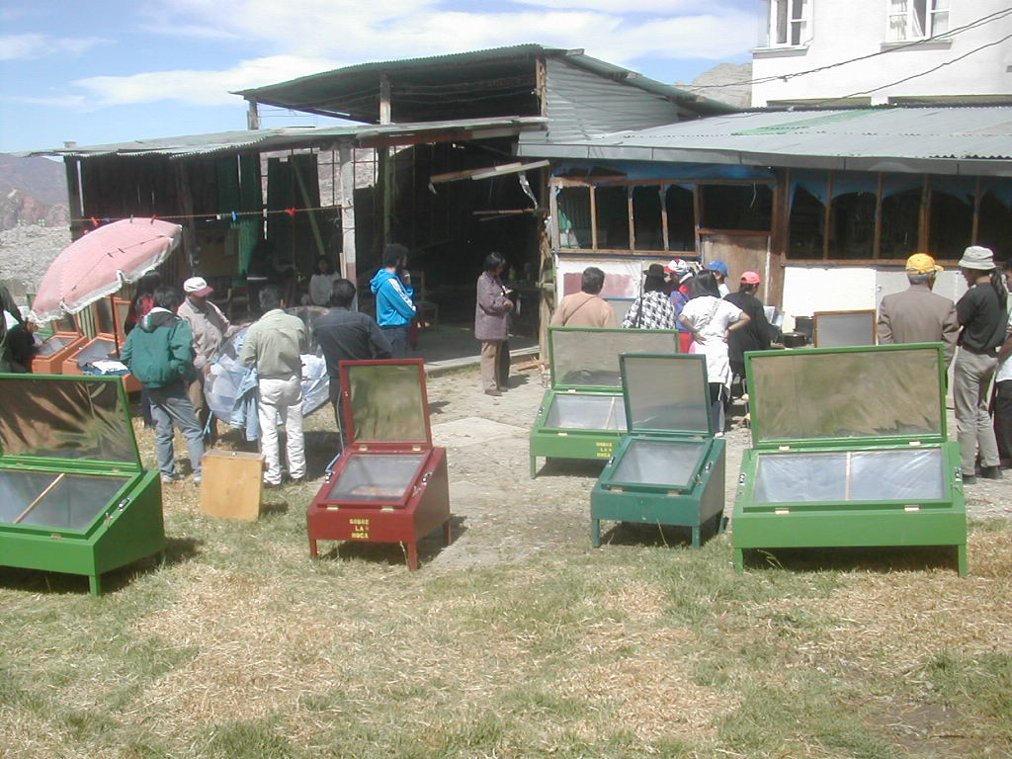

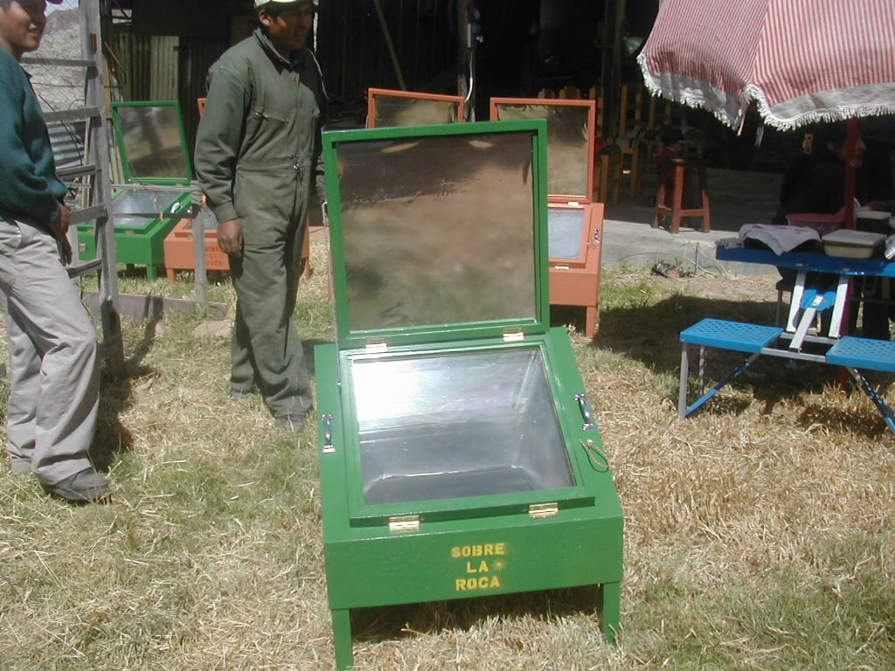

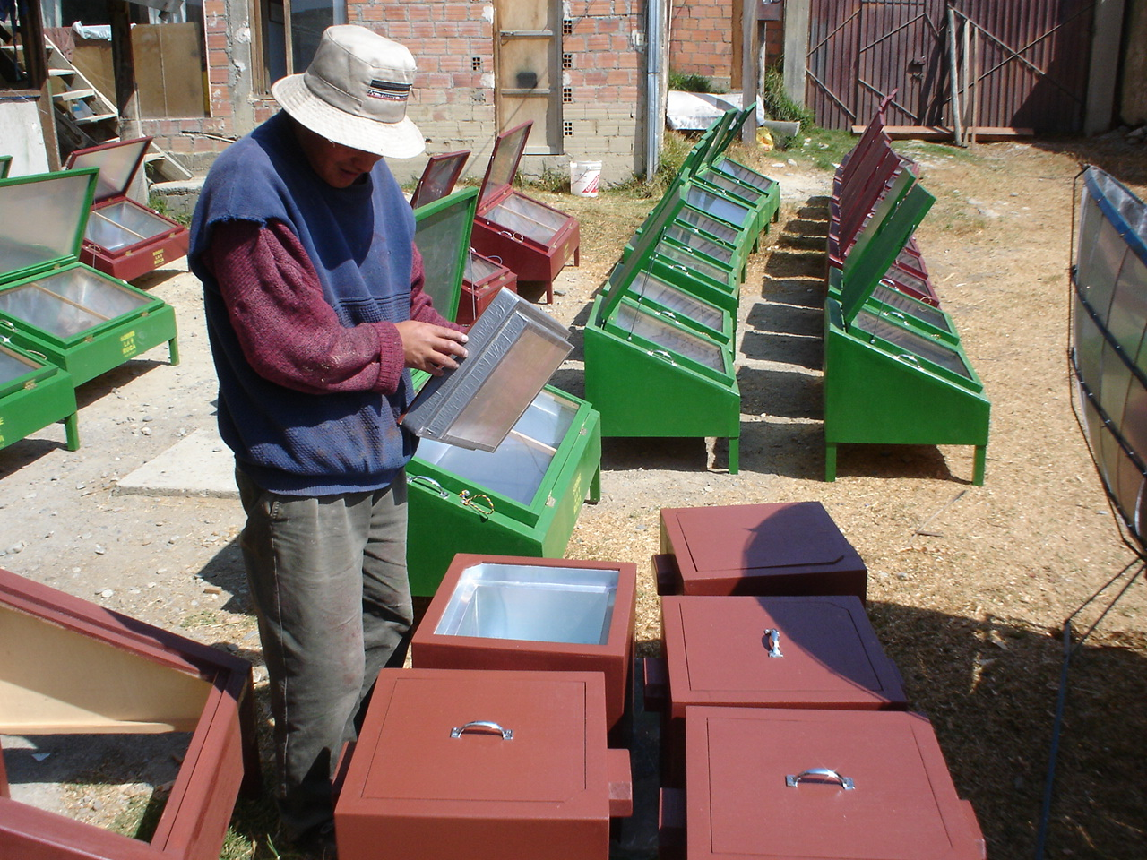
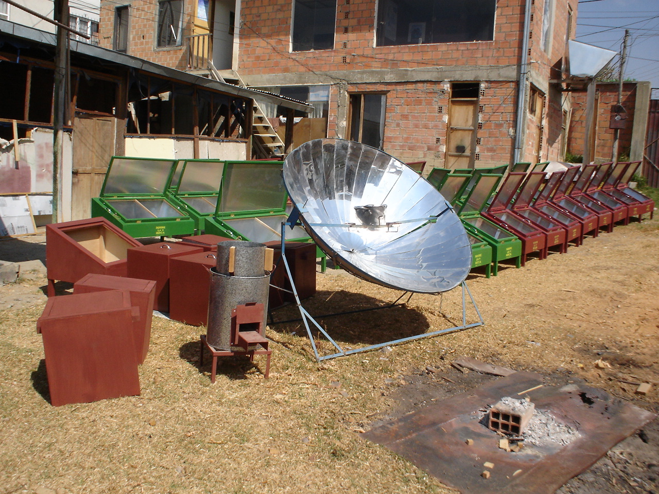
Solar (box, panel and parabolic), retained heat and efficient wood cookers fabricated by the small Bolivian company SOBRE LA ROCA
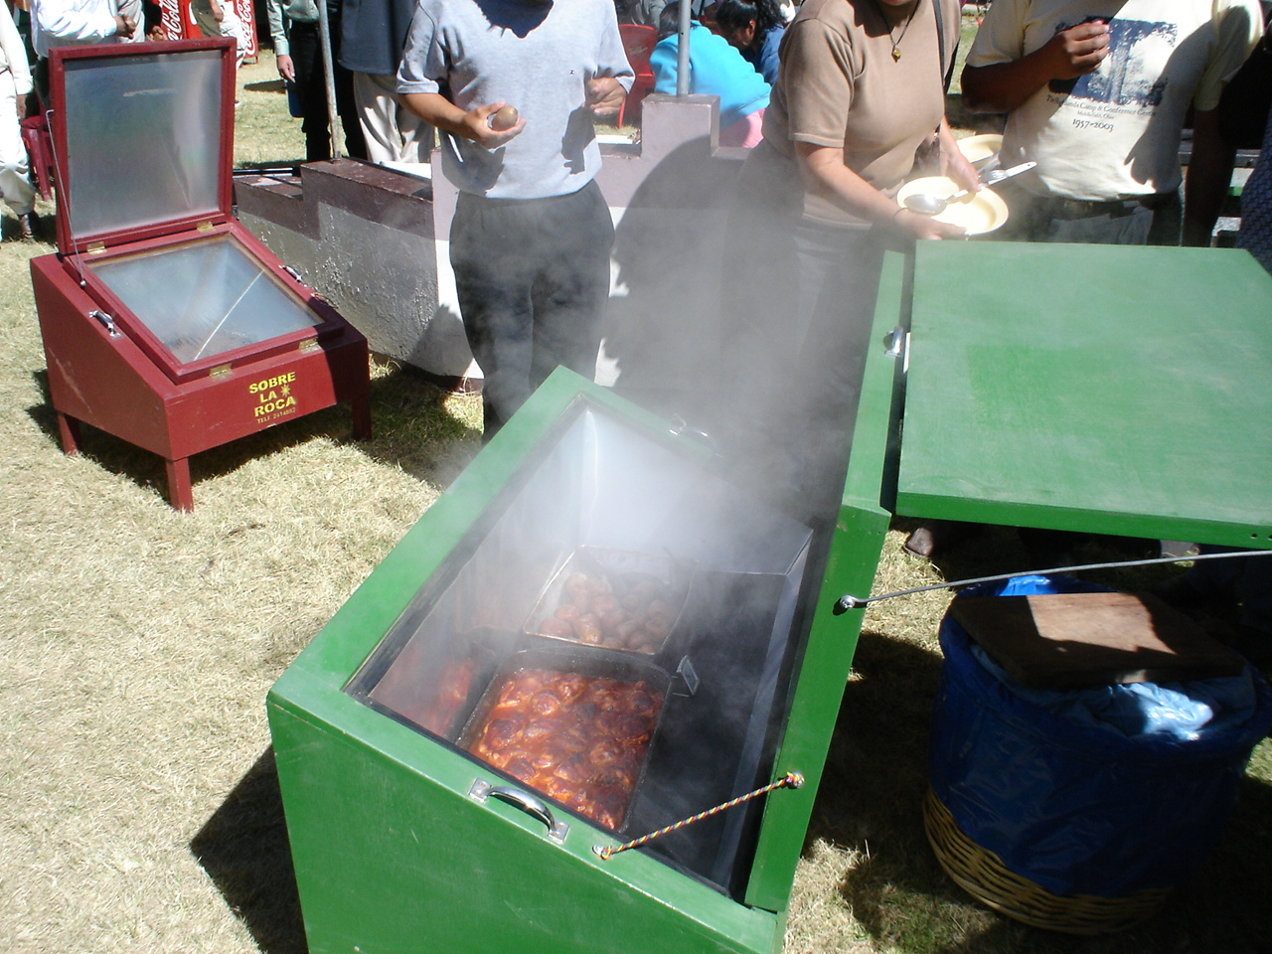
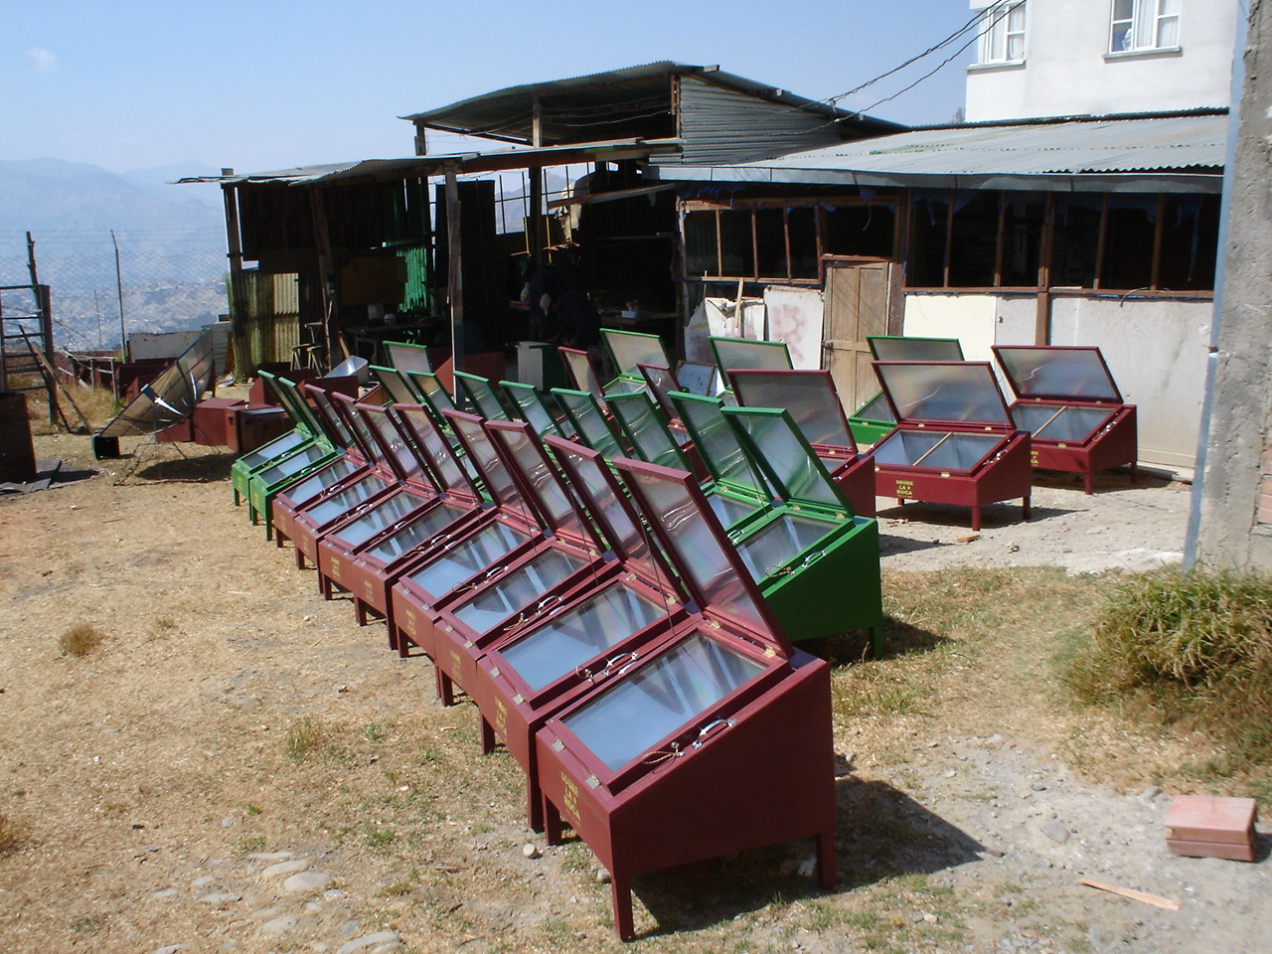

SOBRE LA ROCA produces 2 sizes of solar box cookers
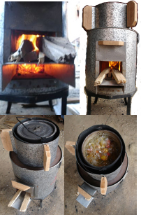

Folks are always impressed to see so much vapor boil out when the solar cooker is opened, and then the real fun begins. . . eating the juicy food cooked in them.

In this case baked chicken and potatoes delighted a group of leaders from all over Bolivia. They couldn’t wait to return to their villages and spread the good news.

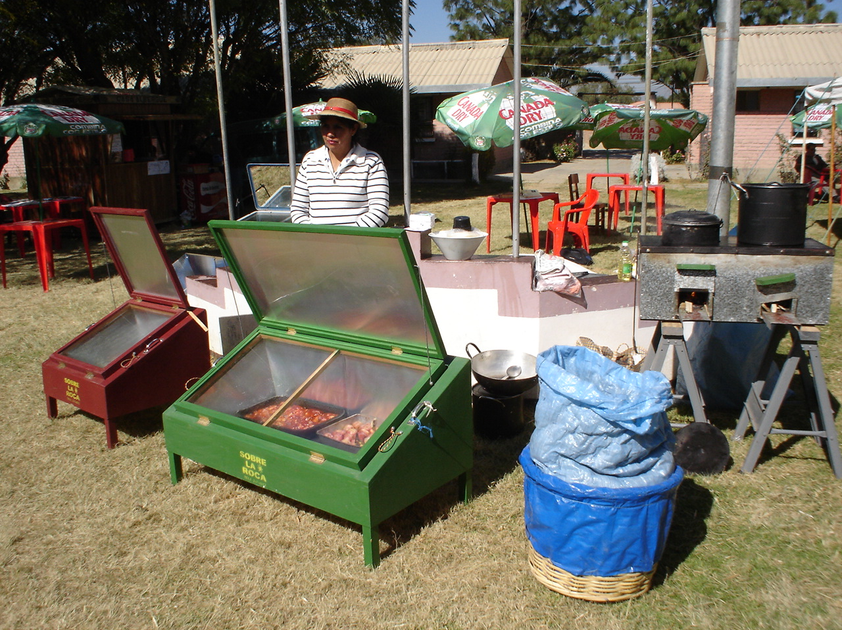
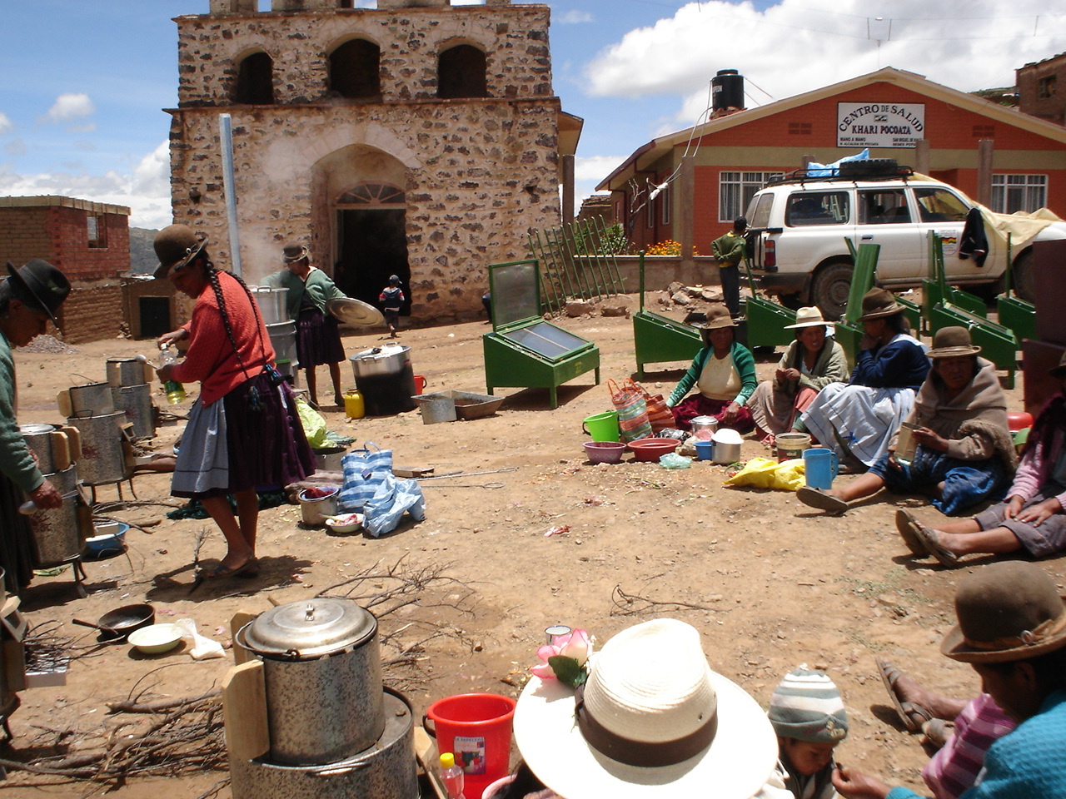
The CEDESOL Foundation (Center for Development with Solar Energy) is actively engaged in reducing indoor air pollution in residences and reducing fuel consumption in schools, predominately in rural areas throughout Bolivia. Solar cookers fabricated by Sobre la Roca are one of the tools used to combat this unseen assassin in the kitchen.

Since November 2005 CEDESOL has been involved in a pilot project introducing Ecological Cookers into rural populations in the arid high mountainous regions of North Potosi Bolivia, in conjunction with a German Technical Cooperation Agency.

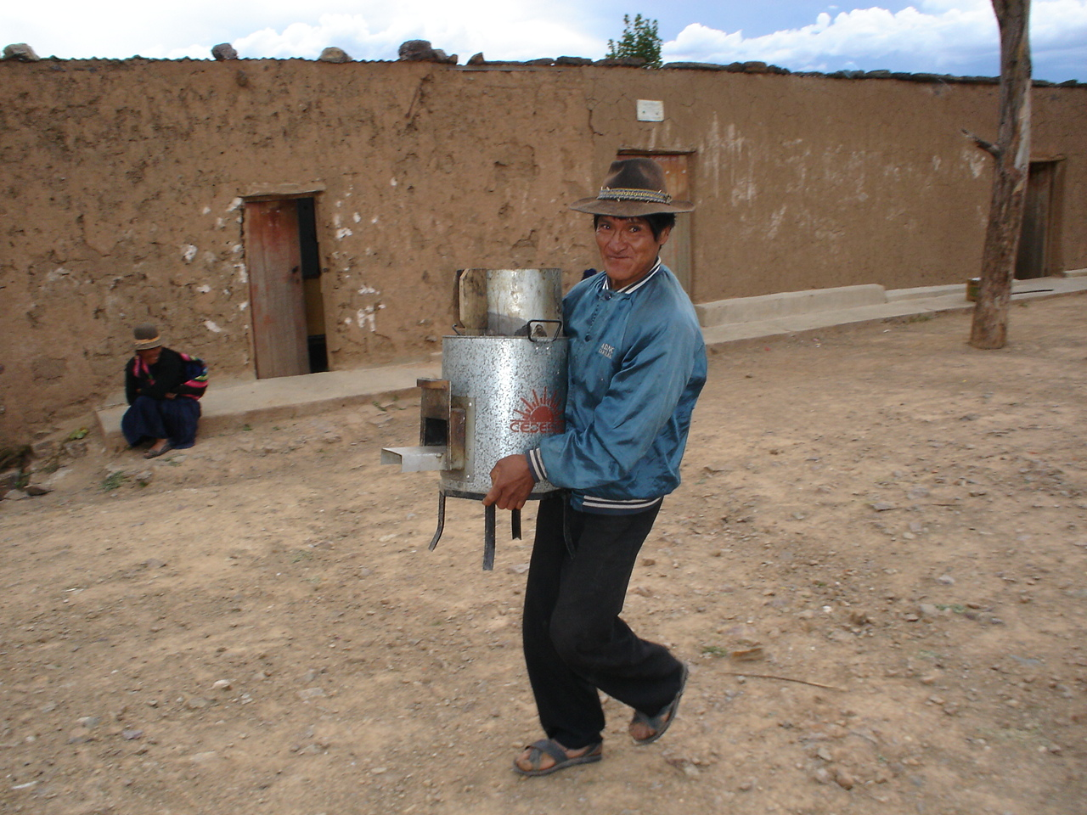
A happy campesino carries his new efficient low fuel biomass stove home.
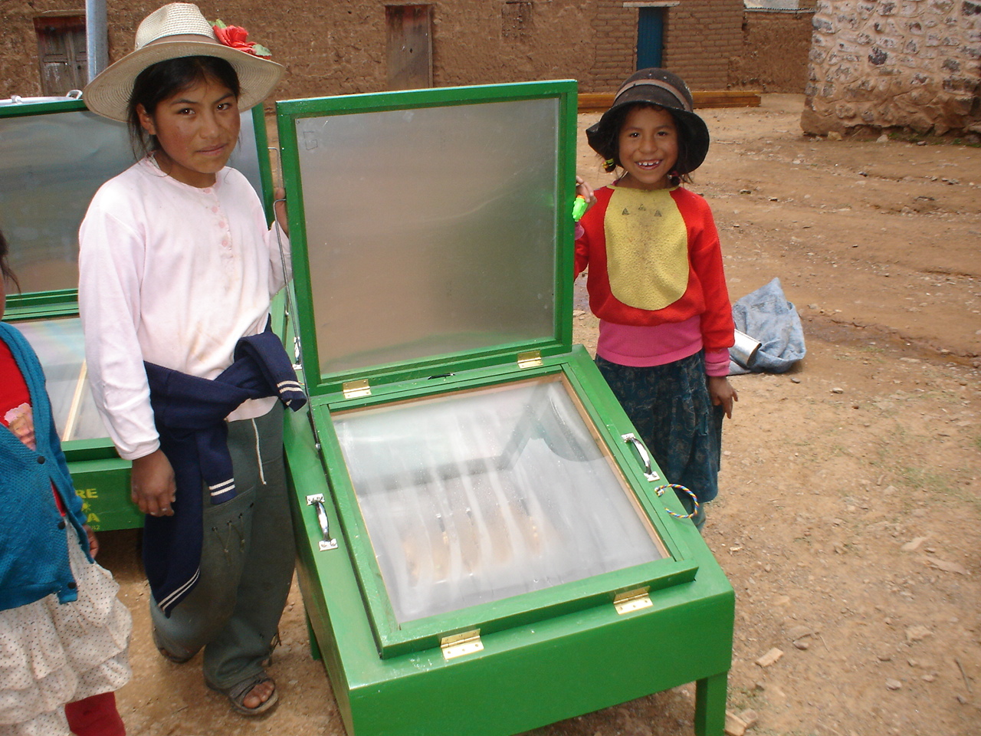

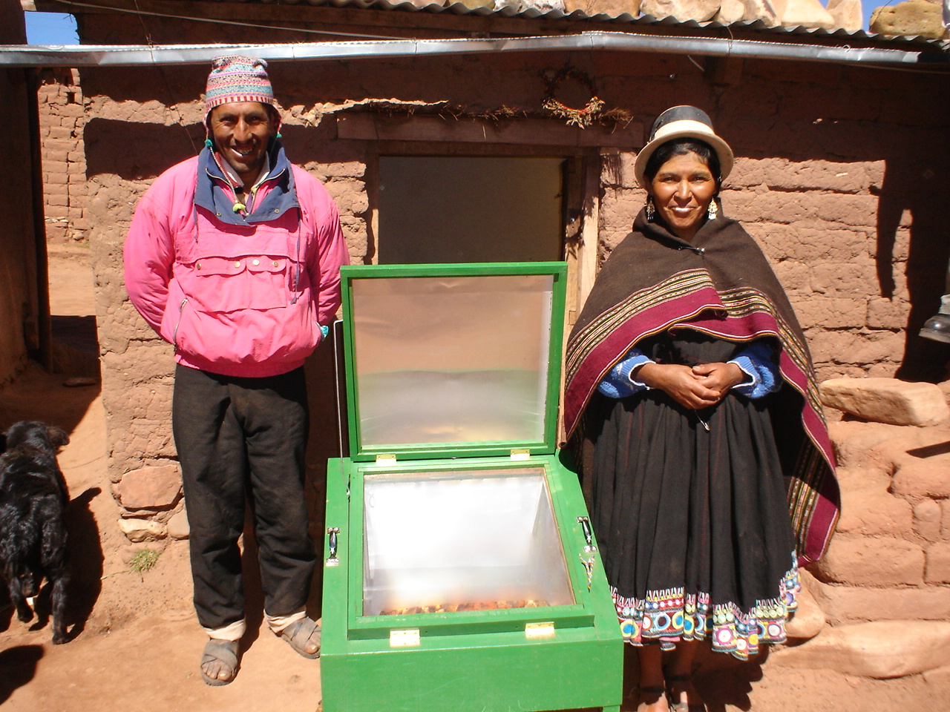
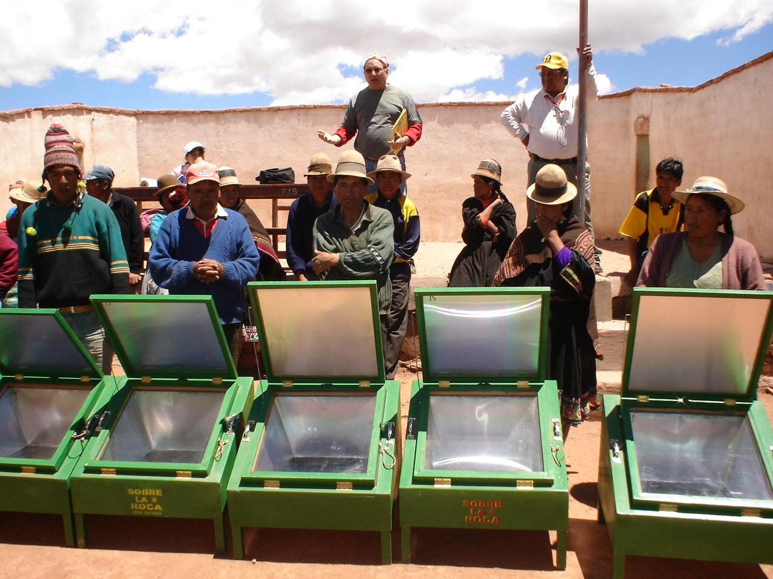

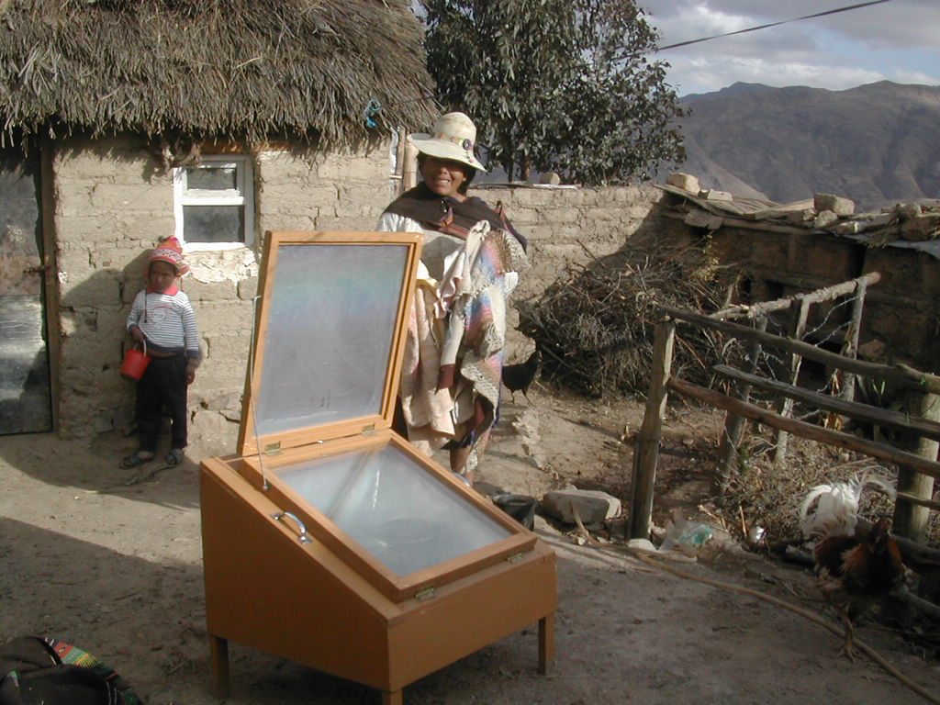

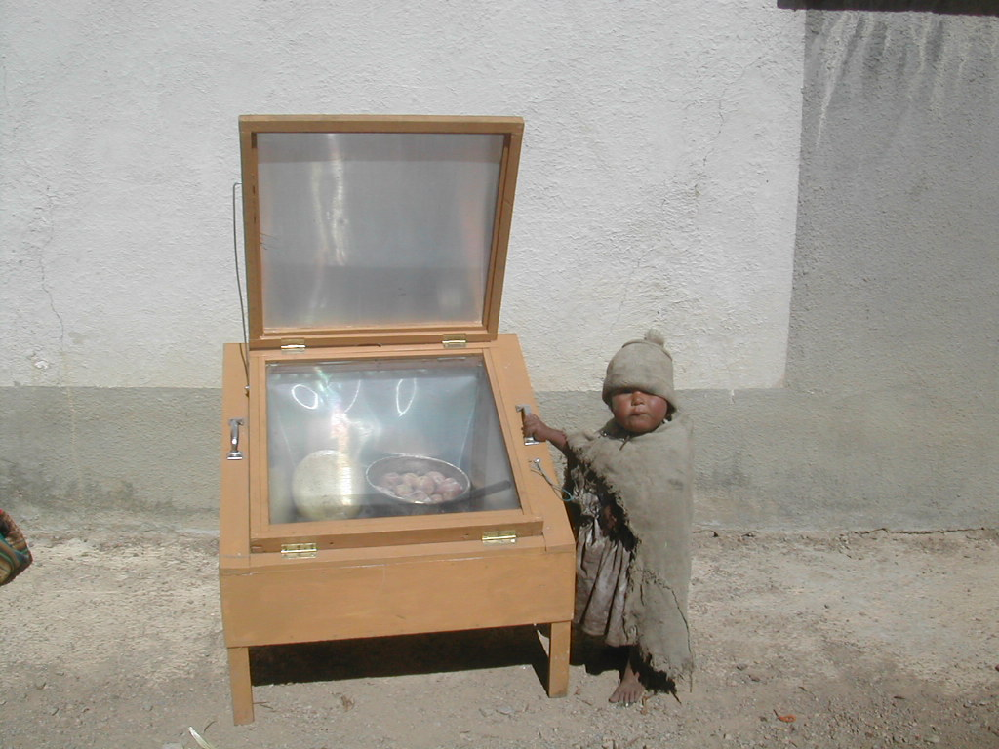
Simple and safe
low cost and
durable.

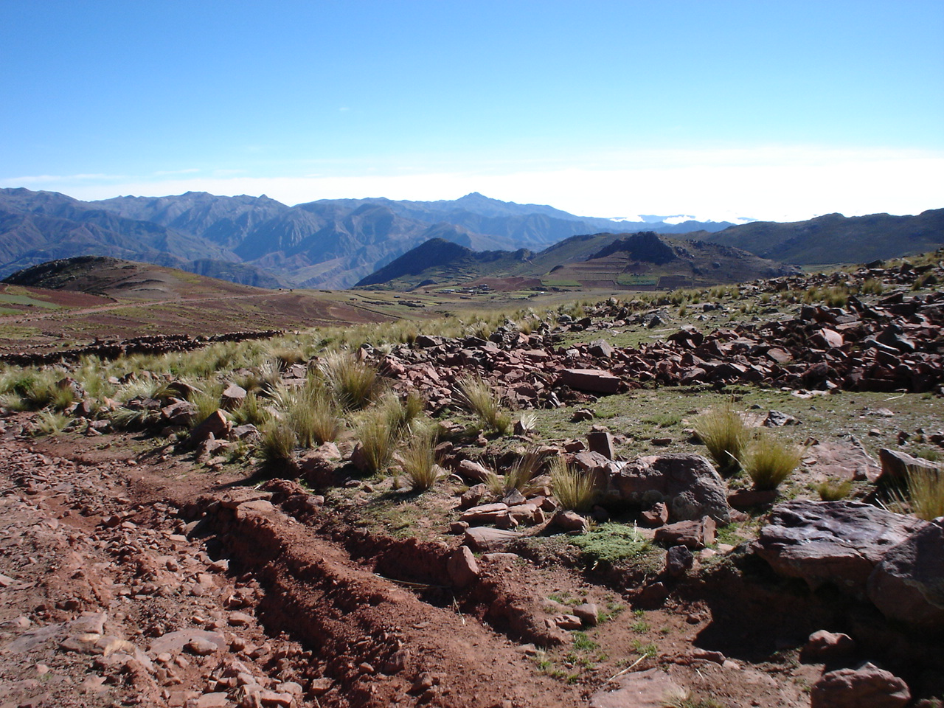

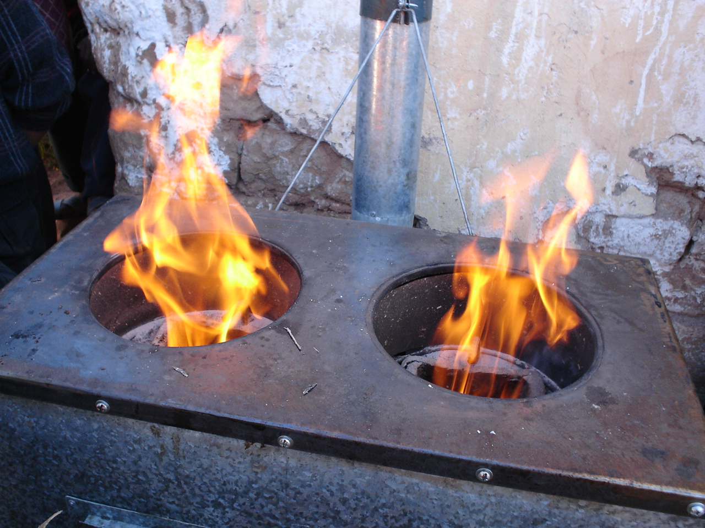
This is the type of roads traveled to get to the areas studied.

With fuel so scarce no wonder folks are excited about this new way of meeting their basic needs.

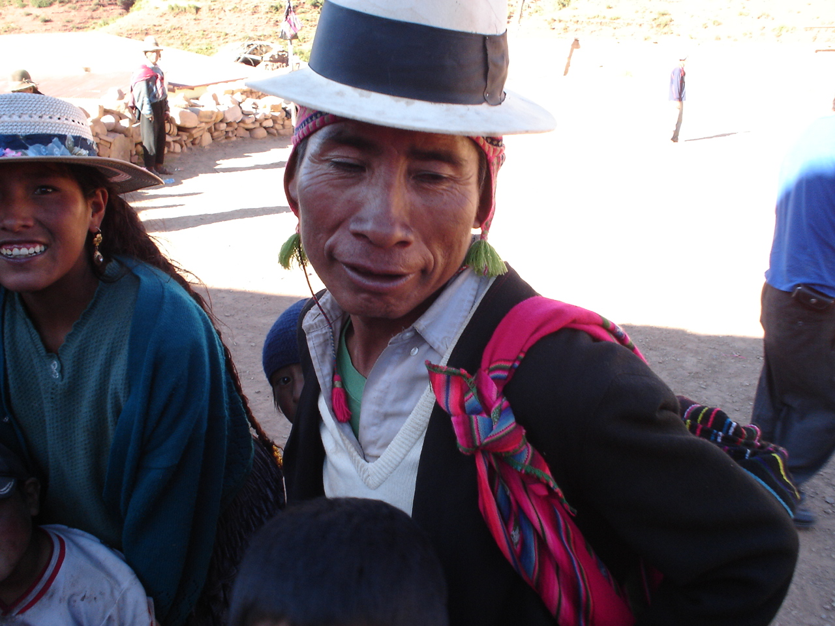

A Quechuan Indian observes in amazement the results of cooking potatoes in a “home made” retained heat cooker.
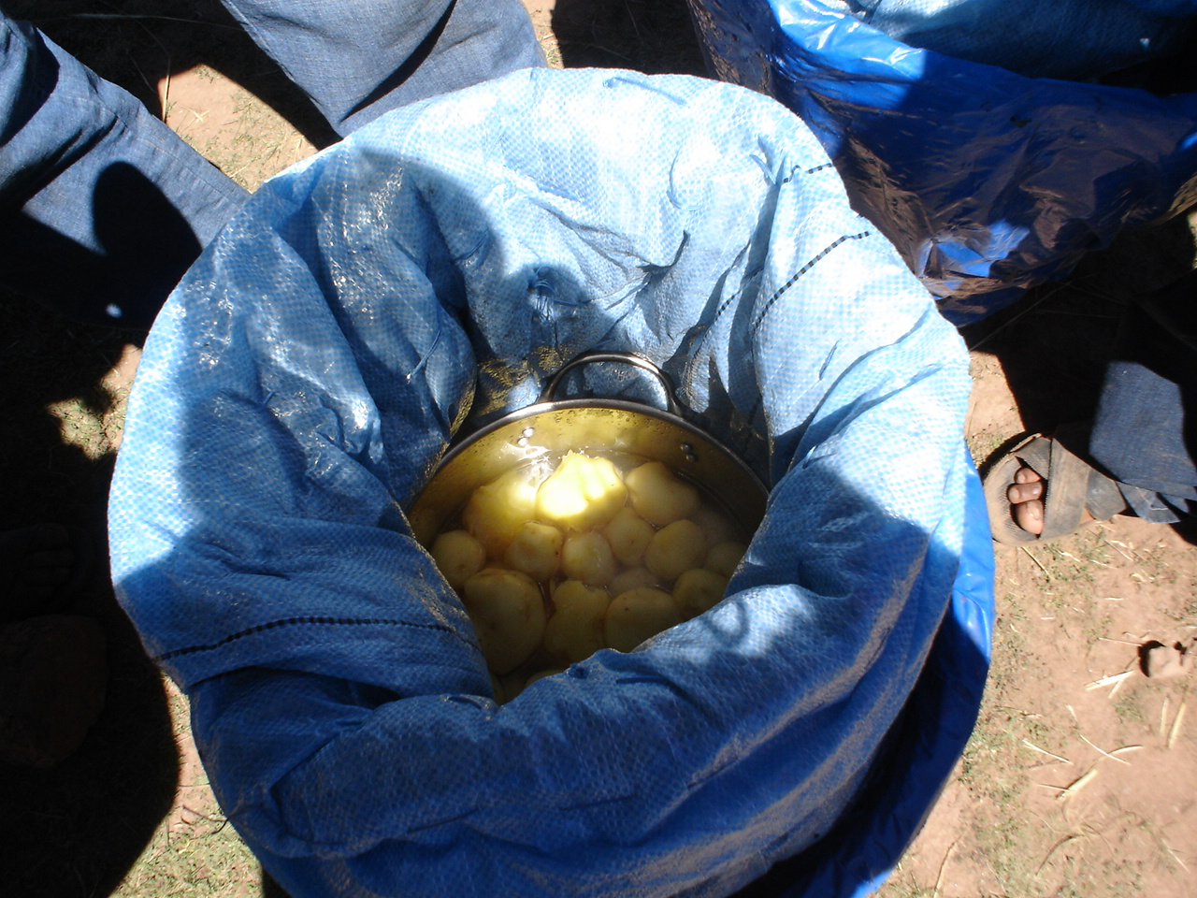

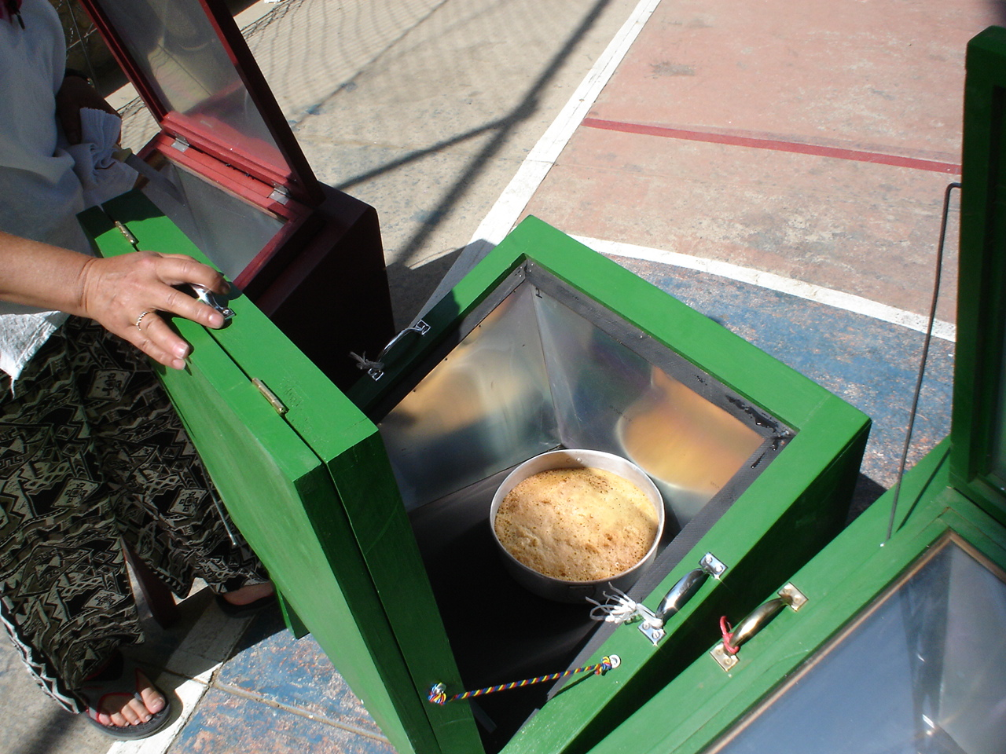

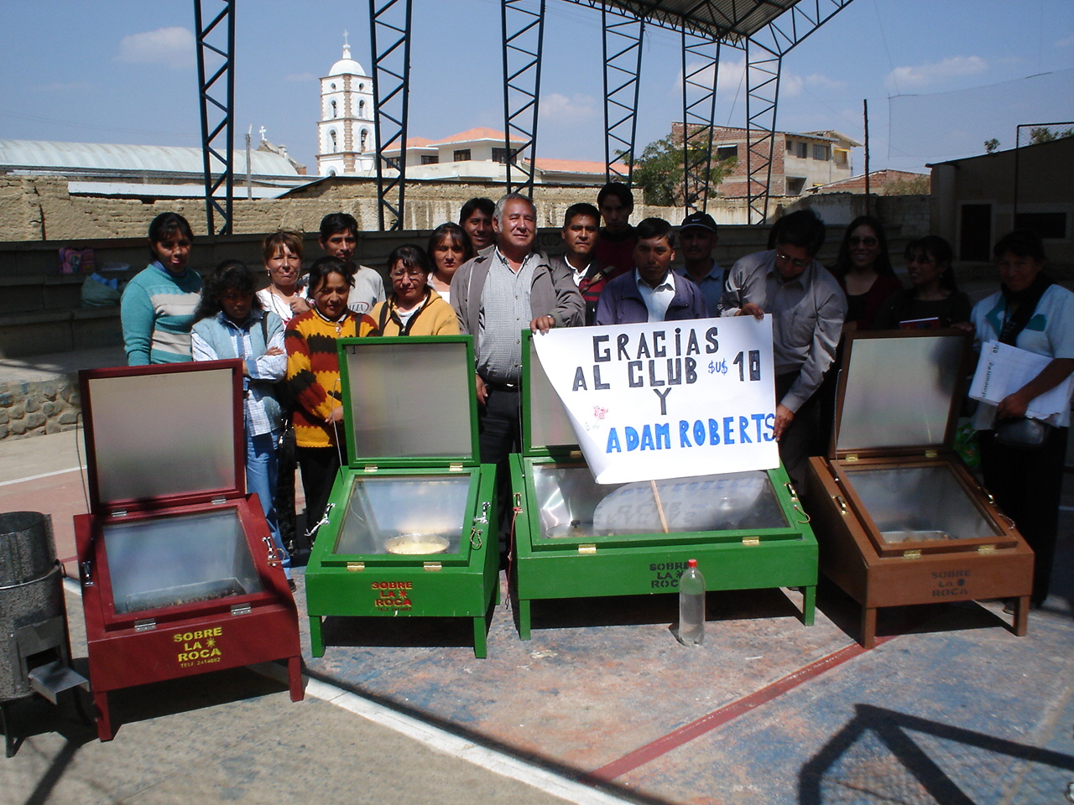
Adam Roberts of the $10 Dollar Club benefited these rural teachers with low cost solar cookers through a

donation. They learned to bake cake as well as cook during their hands on training workshop.

