A Report on Some Experiments with the Top-Lit Up Draft (TLUD) Stove

Dale Andreatta
dandreatta@sealimited.com
January 23, 2007

Abstract

This report contains the results of some experiments with one version of a natural draft Top Lit Up Draft gasifying stove of the “Champion” type developed by Paul Anderson. This stove is an interesting and potentially useful design, but up to now the stove has been studied mainly qualitatively.

It was verified that the stove can be clean burning, and comparable to other stoves in power and efficiency, and the power can be easily controlled. A range of fuels can be burned, however some fuels have better burning characteristics than others and some fuels are not suitable. A table is presented containing details of what fuels can be used in a natural draft device. Details of the burning process such as combustion temperature and burning rates are given.

The report also contains pollutant output results obtained at the Aprovecho Research Center. The effects of primary airflow were determined for a number of conditions by carefully controlling the primary airflow and measuring the fuel loss. Temperature profiles in the fuel bed were measured in order to study the pyrolysis process further. A rough chemical analysis of the air-fuel ratio in the pyrolysis stage is given. This shows that pyrolysis occurs under very oxygen-starved conditions, as would be expected. A basic model of the flow of gases through the stove is also given.

Overview

Top-Lit UpDraft (TLUD) gasifier stoves exist in several forms, some of which use forced air and at least one of which uses strictly natural draft. This report concerns the natural draft type of TLUD stove. The specific test device is essentially the heat-generation components (gasifier and combustor) of Paul Anderson’s Champion Stove that won the 2005 Kirk Smith Cat Pee Award for clean combustion by a natural draft stove. The stove structure (legs, pot support, pot skirt, chimney options etc.) of the Champion Stove are not replicated. A few details were also changed by the author, hence this might be called the “Andreatta TLUD testing device”.

Whatever you call it, this interesting design has good characteristics which make it potentially a very useful design. The good features of the stove are:

- Very low pollution. When running properly the stove makes essentially no smoke and no smell. Carbon monoxide and particulate emissions are very low.

- Constant flame with no user intervention. When running properly, the stove can run for over an hour with strong but not overwhelming flame with no user intervention.

- High temperatures. Stack temperatures consistently measure in the 700-850° C range on an unshielded thermocouple (probably the true temperature is significantly higher). Tests of fuel usage show fuel usage is comparable to other stoves.

- High power and controllability. At the 2005 Stove Camp the stove gave a time of 16 minutes to bring 5 liters of water to a boil. The flame can be then throttled down easily by closing off the inlet air.

- Simple design. The stove has a simple design, with certain dimensions being important, but not critical. Most dimensions can easily be off by 10% from the optimum. As with the rocket stove, the “stove” is not a fixed design, but a set of ideas that can be made out of a number of materials.

- Natural draft. Unlike most other gasifying stoves, only natural draft is used to drive the stove.

The disadvantages with the stove are:

- Fuel sensitivity. The stove is fuel sensitive, with a large part of the fuel needing to be small uniform pieces. Wood pellets are the optimum fuel, though significant amounts of other things can be used. This report begins to explore what other fuels can be used, and in what ratios.

- When the stove operates poorly, it operates very poorly. There are a number of reasons why the stove may start to smoke, and it usually makes a large amount of white smoke. This report begins to look at these situations and what might be done about them.

- Higher pollutants at shut down. The time at which the batch of fuel starts to run out is often a time of higher pollution.

Background of the Design

The TLUD stove burns the wood in 2 stages. As a “particle” of wood is heated it first gives off water vapor, which obviously does not burn. As the temperature of the wood increases hydrocarbon substances are given off in gaseous form. This is called pyrolysis, or pyrolyzing. These gases will burn readily, though if they do not burn completely, due to lack of oxygen for example, some of them condense into droplets that appear as white smoke. These gases are then mixed with secondary air and burned completely. The combustion is separate in time and space from the pyrolysis of the solid fuel, and this is believed to be one of the major factors that gives clean combustion.

After the hydrocarbon gases are driven off what remains is called char, sometimes known as charcoal, which is nearly pure carbon. The char can also burn, mixing with oxygen to form carbon monoxide, which burns to form carbon dioxide. The process by which the char turns into carbon monoxide is properly called gasifying, as distinct from pyrolyzing. The TLUD is probably more properly called a pyrolyzing stove since the fuel is fully pyrolyzed, but only partially gasified.

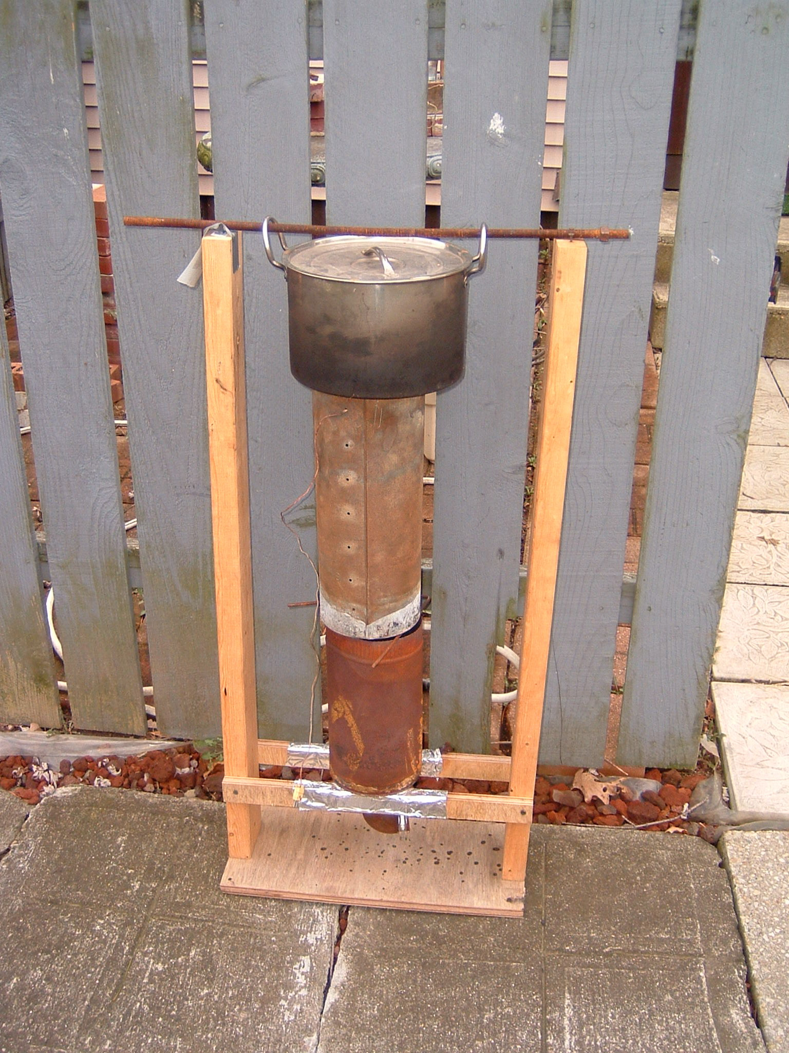
Figure 1: View of the overall stove in its test stand.

The wood is contained in the lower stage of the stove, called the fuel canister. This is typically about 6 inches in diameter and 10 inches tall, with some type of simple grate under the fuel to allow primary air to flow reach the entire bottom of the fuel bed. Currently, the fuel must be mostly small pieces, uniformly filling the canister. Significant-sized pieces can be included, as well as scraps of trash, and small amount of fine fuel. A later section of this report gives more details of what fuel mixtures are acceptable.

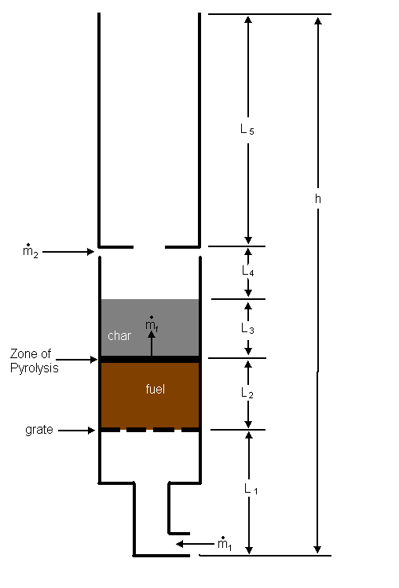
Fig. 2: Cross-sectional drawing of the stove showing the fuel/char bed. Primary and secondary air are given by 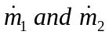respectively. Gases from the pyrolyzing fuel are indicated by 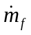, with the “f” indicating “fuel”.

The primary air flows into the bottom of the stove, up through the grate and flows upward through the fuel stack. The words “Up Draft” in the name of the stove refers to this upward flow of primary air. The stack of fuel is lit at the top, with the optimal method of lighting being to light a thin layer of fuel at the top of the cylinder covering the entire top of the fuel bed. The words “Top Lit” in the name of the stove indicate this top lighting.

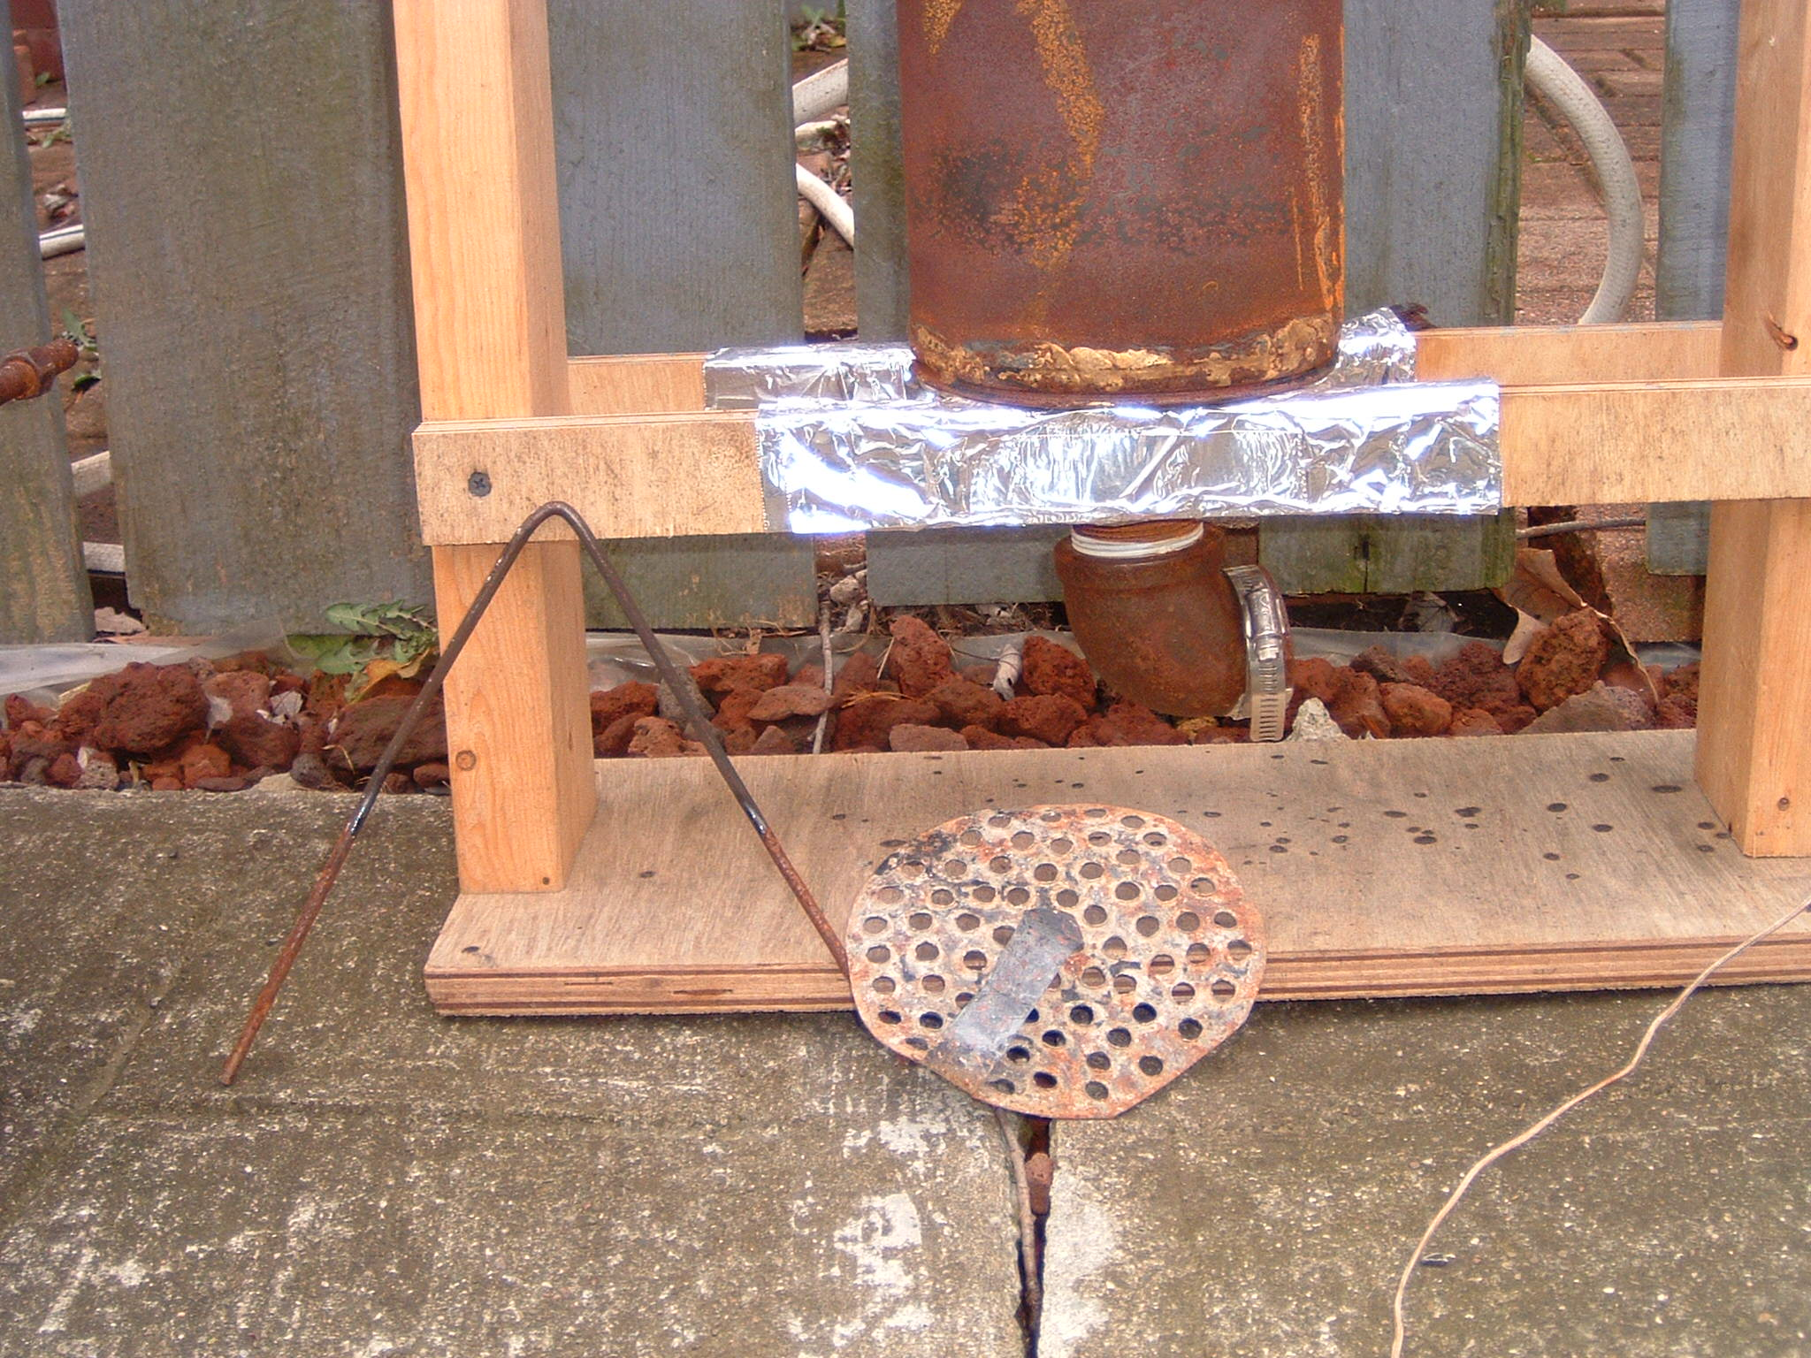
Figure 3: Base of the stove showing the air inlet. The grate and spacer wire are shown removed from the stove.

In the fuel stack there is a pyrolysis zone, that is, a region where the fuel is heating up and giving off combustible gases. This pyrolysis zone starts at the top with the lighting of the fuel and moves slowly down through the fuel stack. Above the pyrolysis zone is char which has previously been pyrolyzed. Below the pyrolysis zone is unburned fuel which is essentially at ambient temperature.

In the char zone there is only partial gasification. By the end of the cooking task there is considerable char remaining, usually 10-35% of the original weight of the fuel. This means a considerable fraction of the carbon atoms originally in the fuel are present in the char, as well as a significant fraction of the energy originally in the fuel. If this char is in a usable form it could be sold or used in a charcoal stove.

In the lower portion of the stove enough heat is released to sustain pyrolysis, but the gases rising through the fuel bed are not fully burned due to insufficient oxygen. The gases contain a large amount of combustible compounds. When the combustible gases mix with the secondary air the combustion is completed, usually in a very turbulent hot flame. The bulk of the air in the stove is the secondary air, which enters in a ring-shaped gap between the top and bottom of the stove. The width of this gap is controlled by a wire bent in a V, the width of the gap being automatically the diameter of the wire, which is typically 1/8 inch or 3/16 inch.

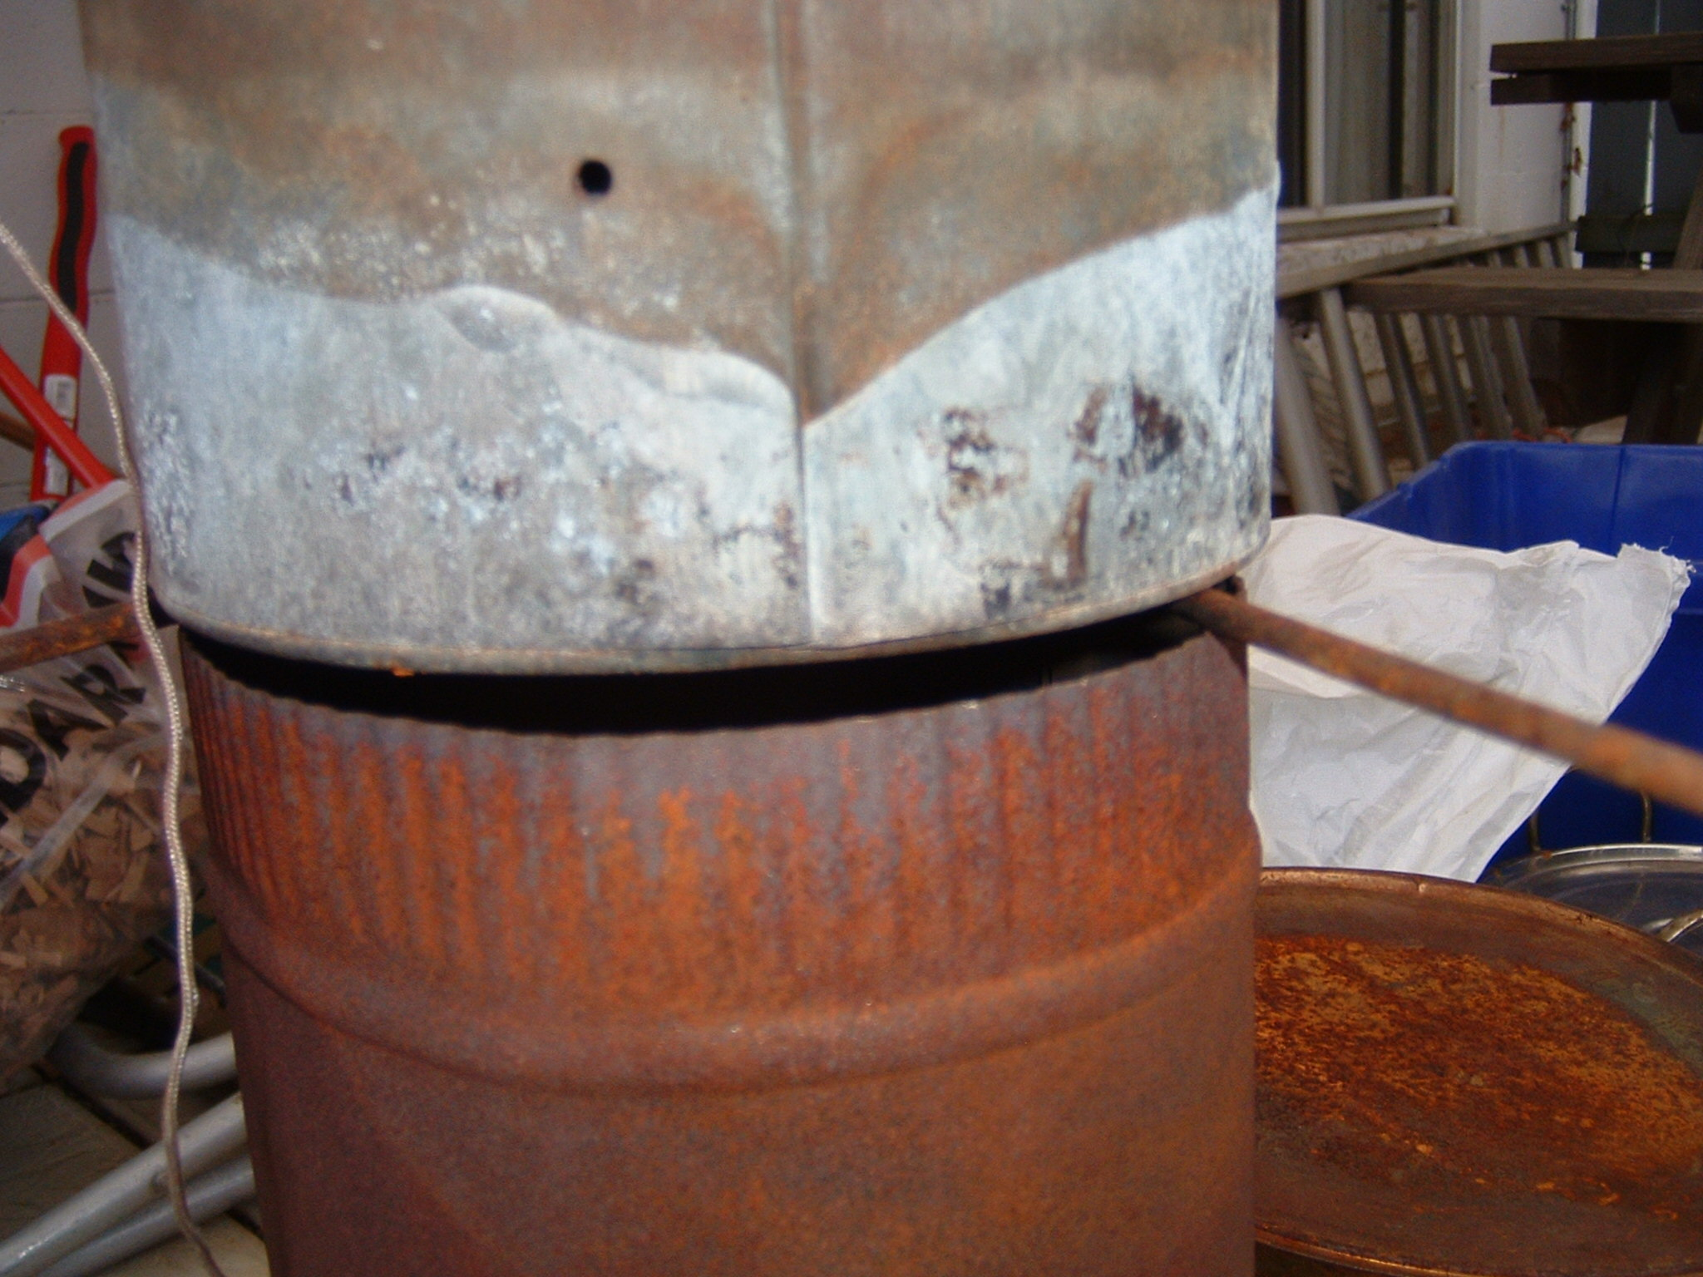
Figure 4: The ring-shaped gap which allow secondary air to enter the stove. The width of the gap is the diameter of the wire, which in this stove was 3/16 inch.

The taller portion of the stove is the upper tube, or riser. Typically, this is 15 inches tall and 6 inches in diameter, the same diameter as the lower portion of the stove. This allows the stove to be made from one 24-inch piece of stove pipe and a few fittings. The inlet to the riser is a 3-inch diameter hole, and both primary air and secondary air flow through this hole along with the combustible gases, which are usually in the process of burning as they pass through the hole. The flame is generally very turbulent, indicating good mixing and it is believed that this good mixing is a major factor in producing the clean combustion.

There are a couple ways to design this 3-inch hole into the system. Figure 5 shows both ways. One way is with a furnace pipe fitting permanently attached to the riser, where the pipe fitting has the hole. Another way is as a separate piece of sheet metal, usually called a concentrating plate. Either way, secondary air must come into the system under the plate, such that it flows through the 3-inch orifice, which is where the mixing occurs.

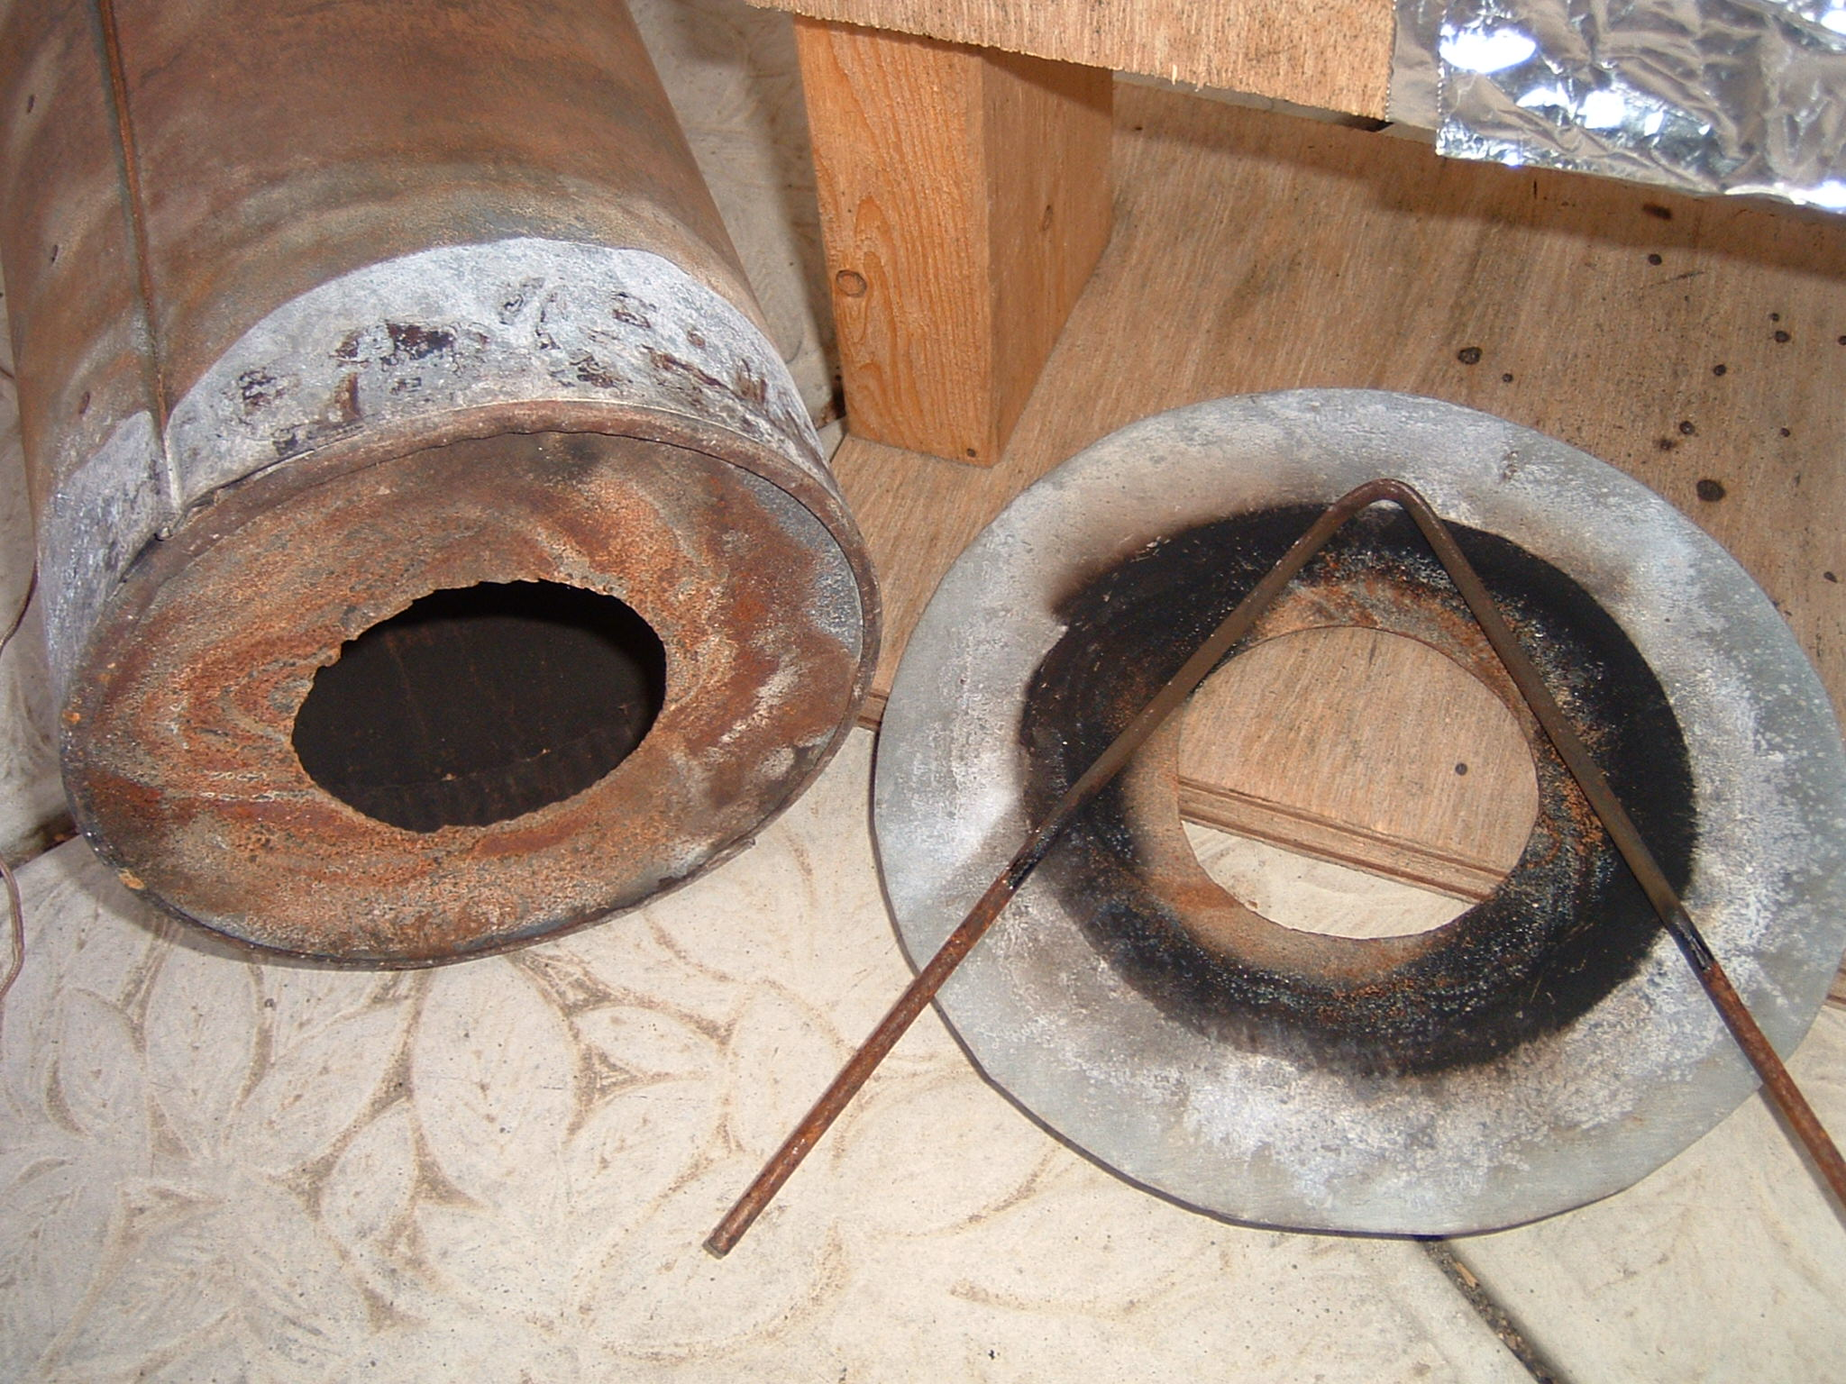
Figure 5: Two forms of the concentrating plate. On the left is a single piece built into the bottom of the riser. On the right is the concentrating plate as a separate piece, with the spacer wire shown as well. The bottom center of the plate is sooty.

The upper portion of the stove (the riser) provides the draft, which sucks secondary air through the ring shaped gap, and sucks primary air up through the fuel. The primary air can be controlled by varying the inlet size at the bottom of the lower canister. This affects the size of the fire in the upper portion of the stove, usually within about 30 seconds. Though the maximum turn down ratio of the stove was not measured, the stove can be throttled from high power to a low enough power level that simmering can’t be maintained with a pot with no lid and no skirt around the pot. If the power level could be further reduced (turndown ratio increased) and if a skirt and lid were available, more fuel could be saved during the simmering phase. (Alan Berick’s recent work says that a lid reduces the amount of power required for simmering by about 75%.) (Berick, 2006)

Experiments Regarding Fuels-General Observations

A wide variety of fuels can be used, at least in some quantities. Wood pellets make an ideal fuel, but obviously are not readily available in the developing world. Other fuels that burn well in combination with wood pellets are dried corn cobs, large pieces of wood (see details below) Styrofoam peanuts, small amounts of paper and various bits of yard waste. Fine fuels such as rice husks or sawdust can be used in small quantities, but only in small quantities. Their fine size tends to block the primary air flow unless a fan or blower is used.

It should be mentioned that using a fan or blower greatly increases the options for fuel usage. Larger canisters of fuel and a wider variety of fuels, especially fine fuels, can be burned with forced air. This report concentrates mainly on the natural draft stove.

The way the fuel lies in the canister is also important. The fuel must be packed uniformly, with no large air gaps in the fuel pack. This can be a problem when using both large and small fuel pieces in the same fuel load. It is believed that the following happens. When the pyrolysis zone reaches the top of the air gap, burning pellets will drop down through the gap, igniting fuel farther down in the fuel stack and turning the system into a bottom-lit or middle-lit stove. The result is that too much fuel is pyrolyzing at once, too much combustible gas is being produced and the stove produces a lot of white smoke. The situation usually corrects itself after a time.

The way in which the combustion process ends varies from test to test and the reason for this variation is not clear. During the normal burning time, the flame is yellow in color and very turbulent. Sometimes the flame will change within the course of a couple minutes to a blue turbulent flame. This flame is smaller and the stack (exit) temperature will decrease to around 300-400° C. This flame often lasts quite a while, diminishing gradually to nothing, with a long period of glowing coals afterward. If the coals are not snuffed out only a little ash remains in the canister after a few hours.

It is known that a blue flame often indicates the presence of carbon monoxide. Measurements under the emission measuring hood shows that only a modest amount of carbon monoxide exits the stove.

At other times, the flame will suddenly die out, usually within a couple minutes. Only dark char (that is, char that is too cool to be red hot) remains, or a small amount of glowing char under a thick bed of dark char. Sometimes, no smoke is produced in this phase, at other times large amounts of white smoke are produced.

Experiments Regarding Fuels-Specific Results

A series of tests were done with a variety of fuels. The results are summarized in the table below. In all tests no lid was used on the pot, and there was no skirt around the pot. (The skirt could not be assured to be the same from test to test, so in order to make the tests comparable to each other, no skirt was used for any test.) A “standard” cooking pot was used with about a 9 5/8 inch bottom diameter and about 7 liter capacity.

Table I: List of tests with specific fuels to test burning characteristics.
Test  Date | Fuel total-  Breakdown | Time to boil  5 liters without lid | Total  Burn time  (Time per  kg of fuel) | Comments
7/28 | 2158 g  100% pellets¹ | Not tested | 75 min  (35 min/kg) | Also see Fig. 8. Very very clean, very uniform flame.
7/30 | 752 g  16% rice husks  84% pellets¹ | Not  Tested | 44 min  (59 min/kg) | Poor burning, cool stack temps, needed to be re-lit, not clean-burning.
8/2 | 1692 g  82% pellets  18% single large log, 3-in. dia. | 36 | 65 min  (38 min/kg) | Generally clean burning with uniform flame. See text below for further details.
7/21 | 745 g  64% pellets  36% sticks⁴ | 17 ½ minutes | 25 min  (34 min/kg) | Hot flame, stove throttled to suit cooking task, generally clean burning.
7/23 | 825 g  38% large sticks⁵  14% small sticks  48% pellets | Did not boil | 30 min  (36 min/kg) | Hot flame, would have boiled in about 30 minutes if more fuel were used. Throttle was varied to keep smoke down, some smoke produced anyway.
7/22 | 717 g  19% large sticks  21% cedar chips  60% pellets | 18 minutes² | 25 min  (35 min/kg) | Fairly clean burning, good size flame.
7/15 | 992 g  33% cedar chips  67% pellets³ | 36 minutes | 40 min  (40 min/kg) | Fairly hot flame, fairly clean burning, stove throttled to minimize smoke.
12/3 | Full canister, about 395 g  100% cedar chips | Not tested | 9-13 min  (23 to 33 min/kg) | Produced moderate flame for 9 minutes, weak flame for 4 minutes. Fairly clean burning.
7/16 | 713 g  56% pellets  44% chips with a few small sticks | 20 minutes | 46 min  (65 min/kg) | Run at lower throttle most of test to reduce smoke, flame not as large or hot.
7/11 | 812 g  29% 1-inch wood cubes  71% pellets | 26 minutes | 34 min  (42 min/kg) | A 3-inch diameter upper section was used. Flame was clean. Stove was throttled to keep smoke down.

¹ Rice husks are very low in density, while the husks were only 16% of the mass, they were 2/3 to ¾ of the volume.
² A smaller quantity of water was used, and the time to boil 5 liters was extrapolated.
³ The cedar chips are low in density; while they make up only 1/3 of the weight, they were about 2/3 of the volume.
⁴ “Sticks” or “small sticks” both refer to small pieces of wood well under 1 inch in diameter. They are mostly silver maple from my yard, dried outdoors.
⁵ “Large sticks” refers to larger pieces of wood, generally 1 inch or a little more in diameter.

It can be seen above that a number of fuels can be used, but that varying the fuel away from pure pellets seems to produce penalties in cleanliness of the burn and non-uniformity of the burn. The burn time per kg of fuel seems to be fairly uniform at about 35 min/kg at full throttle, and somewhat longer at lower throttle settings. This should probably be considered more of a coincidence than anything else, since the primary air flow was not controlled, and even when the primary air flow was controlled (see later test section) the fuel burning rate was not constant across fuels. The exception to this 35 min/kg rule would be with rice husks, which are so fine as to block nearly all of the primary air.

The test of 8/2 deserves special mention. A single large piece, about 3 inches in diameter and 7 inches long was used, surrounded by wood pellets. The purpose of the test was to find the largest size piece that could be used. The large piece was weighed before and after the test. It did not pyrolyze through, and its mass decreased by only 50%, as compared to the normal 80% for fully chared wood. Apparently, about 30% of the original mass of the piece remains as unpyrolyzed hydrocarbons. Splitting the piece revealed that a substantial part of the interior was still the color of the original wood. See photograph below. The wood started out as very dry pine, with a specific density of 0.40. The piece had been protected from the weather for over a year.

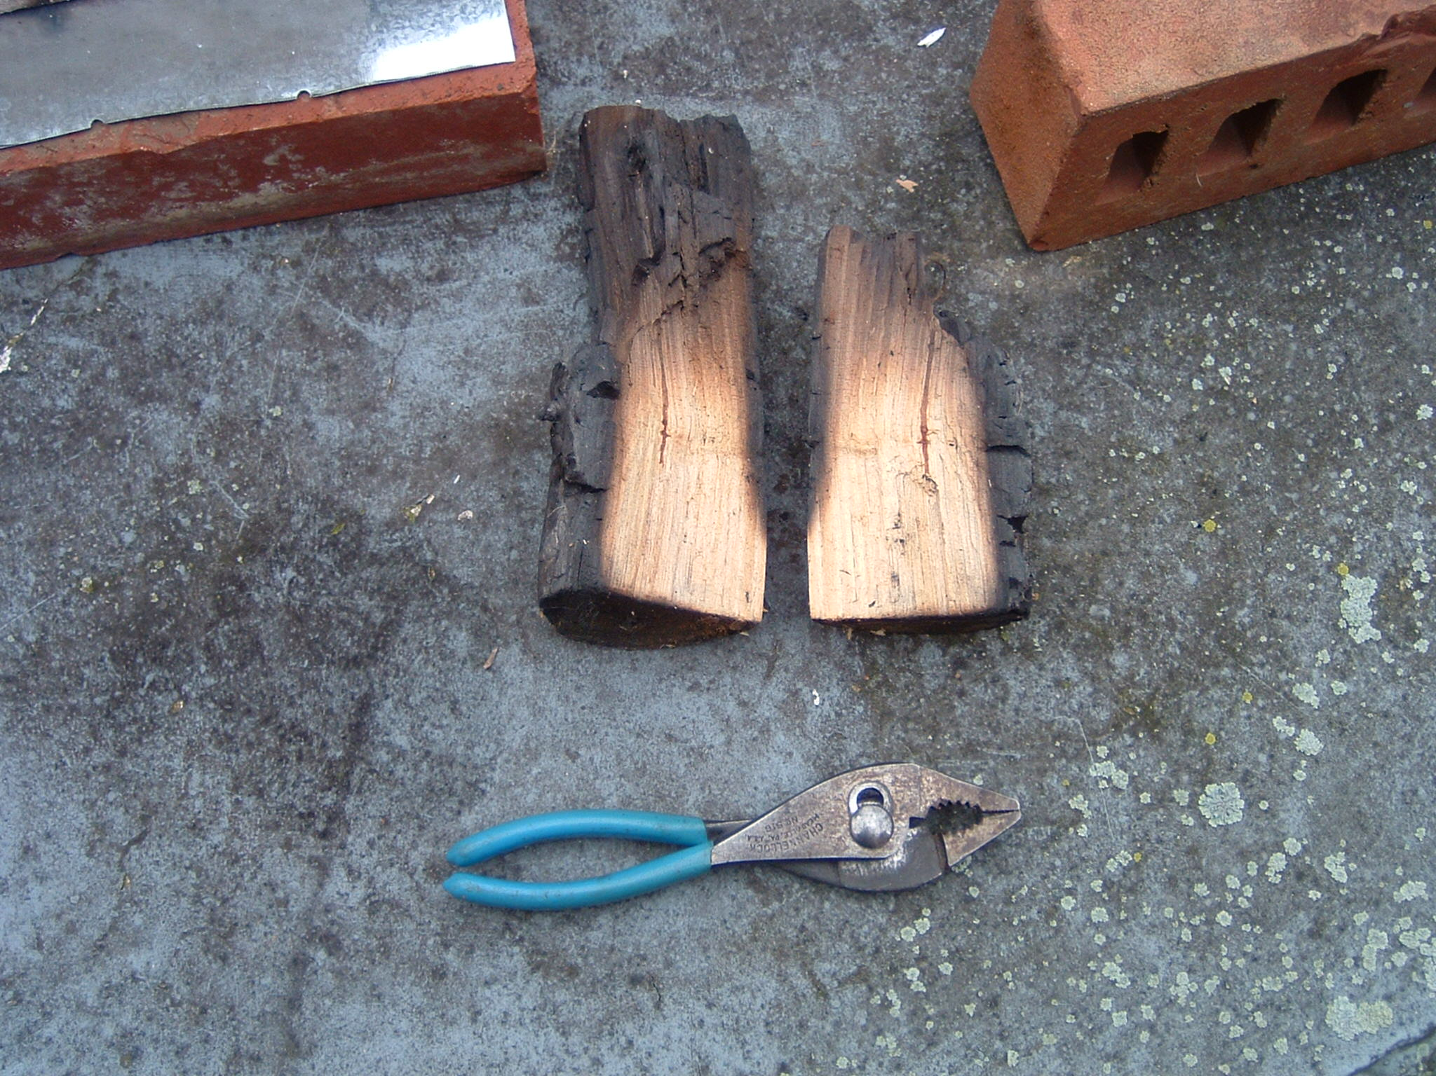
Figure 6: Large piece of wood that was partially pyrolyzed.
One-inch sticks can be burned easily, and even several 1-inch sticks can be burned at a time, but it must be concluded that the upper limit to the size of what will burn well in a TLUD stove is less than 3 inches.

Figure 7 below shows some quantitative results from the 8/2 test. In Fig. 7, flame height in inches above the concentrator plate (the plate that divided the upper and lower parts of the stove) and stack temperature is given as a function of time. The time is the time after the lighting of the match, and the flame takes a while to get going. The stack temperature was with an unshielded thermocouple, so it is likely that the actual gas temperature was higher than that measured, possibly much higher.

Also given in Fig. 7 is the normalized throttle opening, with 10 representing fully open throttle. The lower values of throttle opening are estimated. While this is only an estimate, it can be seen that flame height and stack temperature respond with throttle opening. The throttle setting of 2 is insufficient to keep water simmering without a lid.
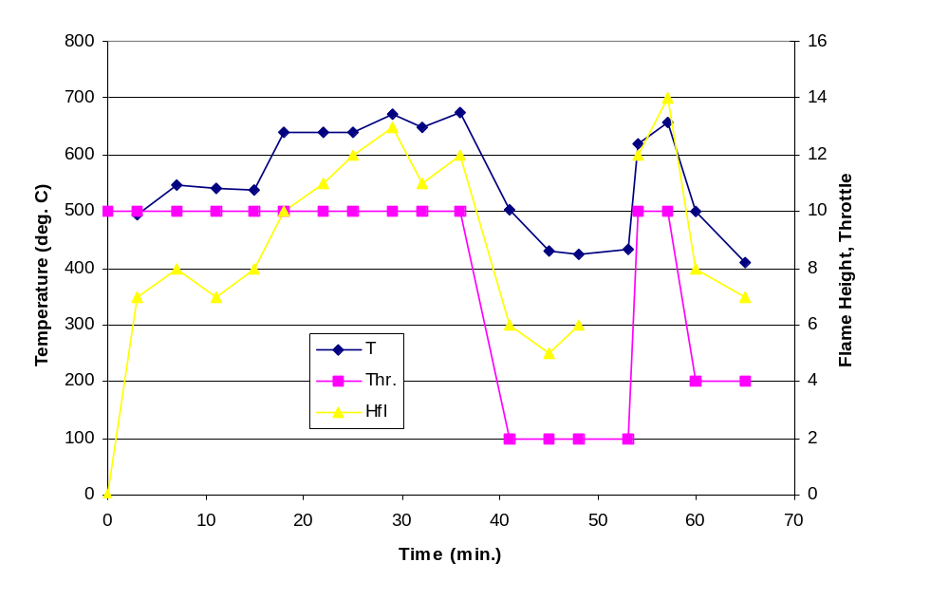
Figure 7: Quantitative results from 8/2 test. Stack temperature, flame height, and throttle opening vs. time.

Measurement of the Pyrolysis Front

In order to examine the pyrolysis front, a test was done with 3 embedded thermocouples in the fuel stack. The fuel stack was 100% pellets, the preferred fuel. The fuel stack was 7 inches deep, with one thermocouple 4 inches above the grate at the bottom of the fuel stack and on the duct centerline (called T1) one thermocouple at the same vertical position but about ½ inch from the edge of the fuel stack (called T2) and one thermocouple 1 inch from the bottom of the fuel stack and on the centerline (called T3).
The 3 temperature profiles are given in Fig. 8. We see that for each thermocouple, the temperature remains near ambient until the pyrolysis front approaches, whereupon the temperature rises rapidly to a peak. The time listed is given in minutes after the lighting of the match. The two thermocouples at the same height see similar temperature profiles, suggesting that the pyrolysis front moves down fairly uniformly.

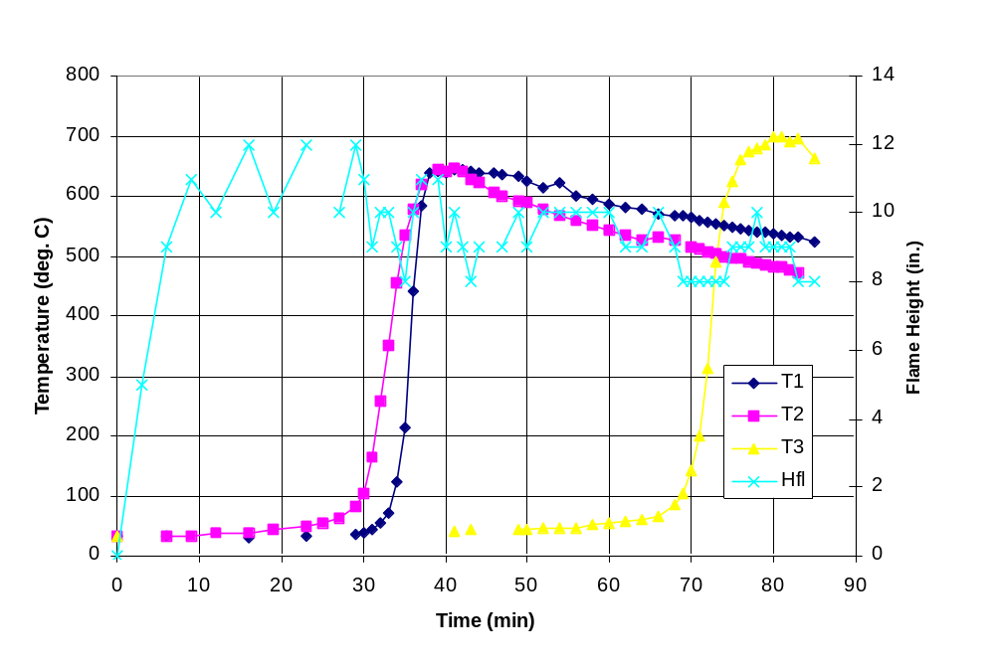Figure 8: Fuel bed temperatures at 3 locations, and flame height.

Also given in Fig. 8 is a graph of flame height, above the concentrator plate. We see that with the throttle fully open, the flame height was fairly uniform for 75 minutes, and that the flame was fully contained in the 15 inch duct. No smoke or smell was noticed at any time between the initial lighting (with the burning of the kerosene) and final flame-out. A pot was not used for this test, however it has been noted that if copious flames strike the bottom of a pot, black smoke is usually produced as a result of the soot particles in the flame being quenched by the cool pot too rapidly. This is true of any stove. It is assumed that had a pot been present in this test, the fact that no flames reached the level of the pot would mean that no black smoke would have been produced and little soot would been left on the pot.

Some other numbers of note for this test are that the amount of fuel used was 2158 g, and 422 g of char was left at the 75 minutes mark. This is 20% of the original fuel weight.

If we define a particular temperature, say 300° C, as marking the arrival of the pyrolysis front, we can estimate the rate of advance of the pyrolysis front. It took 36 minutes for the front to reach thermocouple 1, which was 3 inches down in the fuel stack. This is 0.0833 inches per minute. It took 33 minutes for the front to reach thermocouple 2, also 3 inches down in the fuel stack, and this is 0.091 inches per minute. It took 36 minutes for the pyrolysis front to advance 3 inches from thermocouple 1 to thermocouple 3, a distance of 3 inches, at 0.0833 inches per minute. The flame lasted about 13 minutes after the front reached thermocouple 3, and thermocouple 3 was 1 inch above the grate. We can surmise that the front covered this 1 inch in somewhat less than 13 minutes. Covering 1 inch in 13 minutes is a rate of 0.077 inches per minute. Hence, the speed of the pyrolysis front seems to be pretty constant at about 1 inch per 12 minutes.

An Approximate Heat Balance

For the 7/28 test, the wood burning rate was 2158 g in 75 minutes. Assuming 16 MJ/kg for the wood (dry but not oven dried) gives a heat output of 7673 W. Other tests gave a similar burning rate at open throttle, and a somewhat lower burning rate at lower throttle.

If the stove is burning well, it typically takes about 20 minutes to raise about 5 liters from ambient temperature to boiling, thus the heating rate is about 1220 W delivered to the water. This is with no lid on the pot, thus the actual heating rate will be a little higher. This is about 16% of the heat being produced. This is with no skirt.

The stove is currently made of single wall metal ducting. The mass of the stove is small, and the energy required to heat the stove body is negligible. For the test of 7/28 with the preferred fuel, measurements were made of the stove body temperature using an infrared thermometer at 5 locations on the stove body. The temperatures were in the 250-350° C range, in this test. Other tests produced somewhat higher temperatures.

With the surface temperature known, the heat loss per unit area can be estimated. The bulk of the heat transfer will be by radiation. Once the heat loss per unit area is known, this can be multiplied by the area of the stove to obtain the total heat loss. This heat loss would be about 1900 W, or 25% of the heat being released. It seems that insulating the stove would be a good option to increase efficiency.

Controlled Primary Air Tests

A series of tests was done with a controlled flow of primary air. A lower stove canister was specially prepared by brazing all joints to prevent leakage. A source of compressed air along with a rotameter to measure the flow was used to provide the primary air at a measured rate. The secondary air was unregulated. The rate of mass loss from the fuel was measured, as well as the stack temperature. General observations were made about the cleanliness and quality of the flame.

A few words are in order about what might be learned from such tests. The rate of weight loss is not strictly the burning rate. Some of the weight loss is evaporated water, while some char remains, and at some times of the burning process some amount of char is being gasified. In each test there was a long period with fairly steady mass loss rate.

In some cases the same fuel was used under a variety of air flow rates, while for other tests a standard air flow rate was used for a variety of fuels. This allows us to at least make some generalizations about the effects of primary air flow rate.
The results are summarized in the table below.

Table II: Summary of tests with fixed primary air.
Fuel | Primary air flow (g/sec) | Estimated moisture content (%)¹ | Fuel mass  Reduction rate (g/sec) | % of initial weight remaining as char | Primary air to fuel ratio³
Wood pellets | 0.28 | 0.138 | 0.226 | 0.313² | 1.24
“ “ | 0.47 | “ “ | 0.36 | 0.324² | 1.3
“ “ | 0.70 | “ “ | 0.52 | 0.324² | 1.34
“ “ | 0.94 | “ “ | 0.61 | 0.313² | 1.54
Rice husks | 0.47 | 0.138 | 0.22 | 0.389 | 2.14
Cedar chips | 0.47 | 0.086 | 0.266 | 0.33² | 1.76
“ “ | 0.94 | “ “ | 0.59 | 0.33² | 1.59
Maple twigs | 0.47 | 0.111 | 0.256 | 0.327² | 1.84
“ “ | 0.94 | “ “ | 0.65 | 0.327² | 1.45
Plywood strips | 0.47 | 0.086 | 0.447 | 0.374 | 1.05
Plywood cubes | 0.47 | 0.086 | 0.445 | 0.366 | 1.06

¹ Estimated from the local climate and/or local temperature and humidity using techniques given by Simpson, 1998. Moisture content is defined as the mass of water divided by the mass of perfectly dry wood.
² Average remaining char after 2 tests with different flow rates. That is, the same fuel batch was burned with 2 different air flow rates.
³ The fuel usage rate was assumed in this calculation to be the mass reduction rate.

For the wood pellets, natural draft with an open throttle gave about the same size flame as the 0.47 g/sec air flow (50 std cubic feet per hour). Since other fuels restrict the primary air flow more or less, it is impossible to say how much air flow would been seen in the stove under natural draft conditions. The purpose of this portion of the study was to see the effects of varying primary air.

The above numbers show some trends. One consistent trend is that, as expected, increasing the primary air flow increases the burning rate, the stack temperature, and the flame height. Thus, closing or opening the primary air inlet appears to be a good method for controlling the power of the stove.

One trend that is consistent for pellets is that increasing the air flow increases the burning rate almost proportionally, such that the air-fuel ratio (actually the ratio of primary air flow to wood mass reduction) is nearly constant. The air fuel ratio increases somewhat with increasing air flow.

For the cedar chips and maple twigs the opposite trend is true, increasing the air flow increases the mass burning, but at a less than proportional rate. The air-fuel ratio decreases with air flow rate.

One might expect that there might be a trend of air-fuel ratio with pellet size. This is not the case. One might expect a trend with water content, assuming the estimated water content values are correct. This is also not the case.

When burning properly, all tests gave little or no smoke. For some tests, the flame was more stable than in other tests. In some tests the stove had to be relit.

Pollutant Hood Tests

The TLUD has been tested a total of 3 times under the pollutant hood at the Aprovecho Research Center. Two of these were at the 2005 Stove Camp in Cottage Grove, and the third test was in January 2007 in Creswell. Each test was done with 5 liters of water and included a bring-to-boil phase and a 45-minute simmering phase. The results are given in Table III, along with those from other stoves for comparison. PM is particulate matter. All results are given per liter.

Table III: Test results from pollutant tests.
Stove-Test | CO to boil  g/liter | CO to simmer  g/liter | Total CO  g/liter | PM to boil  mg/liter | PM to simmer  mg/liter | Total PM  mg/liter
TLUD 2005  #1 | 0.33 | 3.16 | 3.49 | 6.5 | 88.2 | 94.7
TLUD 2005  #2 | 0.19 | 2.32 | 2.51 | 7.4 | 53.4 | 60.8
TLUD  2007 | 0.058 | 0.45 | 0.50 | 1.93 | 3.11 | 5.04
Rocket  stove | 0.69 | 1.10 | 1.79 | 15 | 7.7 | 22.7
Wood Gas (fan stove) | 0.82 | 1.02 | 1.84 | 3.79 | 5.73 | 9.52

In each of the 3 tests the TLUD stove produced the bulk of its emissions during the simmering phase. It produced much less emissions in the 2007 test. A likely reason for this is that in the 2005 tests during the simmering phase wood was fed into the stove in a very non-standard way in order to accommodate the standard test. Wood was fed into the top of the stove onto a hot charcoal bed, thus the batch-feed stove was being used as a continuous-feed stove. In the 2007 test strictly batch feed was used, and thus should be a better representation of what the stove is capable of doing. The TLUD stove in the 2007 test performed even better than a fan powered stove in both of the major pollutants.
The fuel in each of the 3 tests was similar, Douglas Fir blocks about 1 cm by 1 cm by 2 or more cm. The January 2007 test wood was probably somewhat moister due to seasonal differences. The blocks were probably somewhat shorter in length in the 2007 test.

In each of the 3 tests the pollutant output was not steady, even when the flame appeared steady. In other words, periods of relatively high pollution would be intermixed with periods of lower pollution, with the stove appearing to operate the same throughout the process. This trend appears to be consistent for both classes of pollutants, in both the high and low power phases of operation. The reasons for this are unknown.

It was confirmed that in general the output of CO is higher as the fuel bed starts to run out, though the pollutant levels are not high enough to make the stove into a highly polluting stove. In the 2007 test, two canisters of fuel were used, and when the end of the canister was reached the smoldering char was moved outdoors. Packing the smoldering char into a snuffer can, a can with a tight-fitting lid, would give similar results. The high CO portion of the test before the char was moved outdoors in included in the pollutant data in Table III.

Comparison of Wood Usage

The wood usage of the TLUD can also be compared to other stoves, however, this will be a more of a function of how the heat is used rather than a function of how the heat is generated. The results for a number of tests are given below in Table IV. The time to bring 5 liters to a boil is given as total minutes for 5 liters, and was corrected for the initial starting temperature. Fuel usage is given in grams per liter. All but the TLUD 2007 test were from the August 2005 Stove Camp. The same notes as given above apply to the tests.

Table IV: Wood usage and time to boil for several stoves.
Stove – Test | Time to boil 5 liters (min) | Fuel to boil  g/liter | Fuel to simmer  g/liter | Total fuel  g/liter
TLUD 2005 #1 | 15.3 | 46 | 93.7 | 139.7
TLUD 2005 #2 | 34.7 | 141.8 | 78.3 | 220.1
TLUD 2007 | 26.3 | 117.4 | 213.9 | 331.3
Optimized Rocket | 18.5 | 54.2 | 26.5 | 80.7
WFP Rocket | 13.7 | 54.1 | 37.6 | 91.7
Bangladesh Mud Stove | 49.5 | 120.1 | 50.2 | 170.3

The TLUD 2005 #1 test featured an insulated skirt, and thus gave a quick time to boil and lower fuel usage. The TLUD 2005 #2 test had the pot on a plancha with a hole, thus no hot gases reached the sides of the pot. Time to boil was very slow and fuel usage was high. The 2007 TLUD test also had no skirt, hence fuel usage was very high and time to boil was slow. Also, this stove had thin metal uninsulated walls, hence it probably lost something like 25% of the heat through the sides of the stove. (See the section giving an approximate energy balance.)

It appears that if the TLUD is designed for efficient heat transfer its fuel usage can be comparable to other stoves, though perhaps not as good as an optimized rocket stove. If the stove is poorly design in terms of efficiency, as in the 2007 test, the fuel usage will be high. Again, this is a function not of the TLUD combustion process, but of the details of the stove.

A Chemical Analysis

One can perform further analysis based on the above numbers from the tests with constant primary air. A paper by Bhattacharya, et. al, 2002 gives some numbers for the chemical content of dry wood. Their wood was 51.2% carbon by mass, 7.31% hydrogen, and 39.03% oxygen. This allows us to calculate that a typical “atom” of dry wood is 0.3044 atoms of carbon, 0.52155 atoms of hydrogen, and 0.1741 atoms of oxygen. The “atomic mass” of an atom of wood is thus 6.954.

For this analysis assume that all organic matter has about the same chemical composition. One can estimate the water content from the estimated % moisture values. Wet wood can be assumed to be:

0.3044C + 0.52155H + 0.1741O + aH₂O (Eq. 1)

where a is given by:

a = (%Moisture/100) * 6.954/18 (Eq. 2)

If combustion is assumed to be complete except for the char that remains (which was measured at the end of each test) the stoichiometric combustion formula can be written as:

0.3044C + 0.52155H + 0.1741O + aH₂O + b(O₂ + 3.76N₂) ======➔

kC + (0.3044-k)CO₂ + dH₂O + 3.76bN₂ (Eq. 3)

d is calculated from a hydrogen balance as

d = (0.52155+2a)/2 (Eq. 4)

and k is given by the fraction of the initial fuel weight remaining as char

k = (%char/100) * (6.954+18a)/12 (Eq. 5)

A k of 0.3044 would mean that all the carbon went into char and none into CO₂. The char was assumed to be pure carbon.

Air is assumed to be 1 part oxygen and 3.76 parts nitrogen.

Parameter b is calculated from an oxygen balance:

0.1741 + a + 2b = 2(0.3044-k) + d (Eq. 6)

The theoretical stoichiometric air to fuel ratio can be calculated from:

AFR = b * 137.28/(6.954 + 18a – 12k) (Eq. 7)

Finally, the equivalence ratio can be calculated. This is the stoichiometric air to fuel ratio from Eq. 7 divided by the actual air to fuel ratio from Table II. An equivalence ratio greater than 1 implies rich combustion, where all of the oxygen is consumed but not all of the fuel. An equivalence ratio less than 1 implies the opposite.

The fact that significant secondary combustion occurs where the secondary air enters the stove proves that not all the pyrolysis gases are consumed. (It would be possible, however, to have both fuel and oxygen present in the gases above the pyrolysis zone if there were poor mixing of the fuel and air. This would be more likely with larger fuel pellets and/or non-uniformly stacked fuel.) From the presence of the large secondary combustion flames, we expect that the equivalence ratio will be significantly greater than 1. The following table gives the results.

Table V: Results of calculations regarding fixed primary air tests.
Fuel | Air (g/sec) | AFR measured | K | AFR stoichiometric | Equivalence Ratio
Pellets | 0.28 | 1.24 | 0.2064 | 3.57 | 2.88
“ “ | 0.47 | 1.30 | 0.2137 | 3.44 | 2.65
“ “ | 0.70 | 1.34 | .2137 | 3.44 | 2.57
“ “ | 0.94 | 1.54 | 0.2064 | 3.57 | 2.32
Rice husks | 0.47 | 2.14 | 0.2565 | 2.56 | 1.20
Cedar chips | 0.47 | 1.76 | 0.2077 | 3.8 | 2.16
“ “ | 0.94 | 1.59 | 0.2077 | 3.8 | 2.39
Maple twigs | 0.47 | 1.85 | 0.2105 | 3.62 | 1.96
“ “ | 0.94 | 1.45 | 0.2105 | 3.62 | 2.50
Plywood strips | 0.47 | 1.05 | 0.2354 | 3.26 | 3.10
Plywood cubes | 0.47 | 1.06 | 0.2303 | 3.37 | 3.18
As expected, the equivalence ratios calculated for the first stage of combustion are much greater than 1.

A number of points can be noted from the above. For all the fuels about 2/3 of the carbon atoms remain as char if the pyrolysis is stopped immediately after the flame dies out. This char could potentially be sold, hence the stove user would cook and manufacture a product at the same time. This would be a way around the significant energy wastage associated with making charcoal.

Alternatively, the char could be buried or sequestered and the stove would become a greenhouse gas mitigator with about 3 times more CO₂ being pulled out of the atmosphere when the wood grows than is being put into the air by the burning of the fuel. This is especially true since the stove produces low levels of CO and black carbon (black smoke). Carbon monoxide and especially black carbon are much worse than CO₂ in terms of global warming (Bond, Vankataraman, and Masera, 2004). There are also reports that char can improve the quality of certain soils.

Of course the above analysis makes some broad assumptions. The wood is assumed to burn in one stage, with no effort to distinguish pyrolysis from gasifying. The chemical content of the wood is assumed to be exactly that given. No ash is included in the analysis, which is probably a good assumption except for the rice husks. The original moisture content of the wood is only approximately known.

A Rudimentary Model

This section presents an effort to model the TLUD stove in a very rudimentary fashion. The figure below shows the nomenclature used in the analysis, and an approximate pressure curve for the air inside and outside the stove.

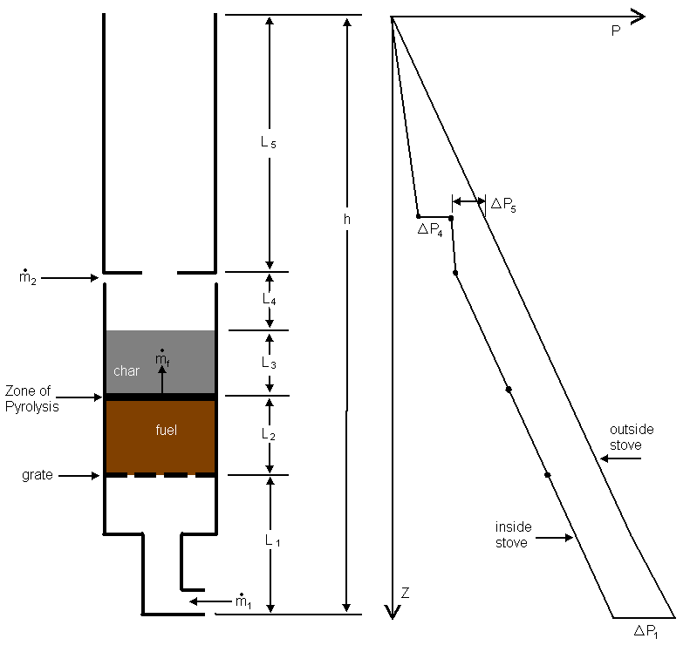
Figure 9: Cross section of the stove, and a pressure curve.

It is assumed that the air above the pyrolysis zone is at 600° C, both in the fuel bed and in the secondary combustion zone in order to calculate a hot zone density. Measurements show that this is approximately correct, and this number is only used to calculate the hot zone density, so this assumption should not be critical to the analysis. Air outside the stove, and in the stove below the pyrolysis zone is assumed to be 27 °C. Again, this is only used to calculate an air density.

In the section on fuel-bed temperature profiles, it was recorded that the temperature of the fuel bed was essentially the ambient temperature until the pyrolysis front approaches, then the temperature of char was nearly constant for the remainder of the burn process. Thus, the 2-zone density model used here should be acceptable.

The pressure curve in the above figure deserves comment. The pressure is assumed to be zero at the top of the stove, and is assumed equal on the inside and outside of the stove at that point. If one were to travel down the outside of the stove to the bottom of the stove, the pressure would increase at a rate proportional to the density of the air outside the stove, which is high. This is the right line in the pressure curve. The total height of the stove, h, is about 26 inches or 0.65 meters, thus the total change in pressure is about 7.6 Pa.

As air goes through the stove is sees a sudden pressure drop as it goes through the entrance restriction, this is ΔP₁. As the air goes up its pressure goes down due to gravity. Then the air sees a pressure loss while going through the fuel/char bed. This is partly due to gravity, but partly due to the flow restriction of the fuel.

As the air comes out the top of the char layer it is hot, and as the air ascends it looses pressure, though the pressure gradient with height is smaller, since the density is less that it was outside the stove.

There is a sudden pressure drop as the burning gases flow through the hole in the concentrator disk. This is shown as ΔP₄. Then the air looses pressure as it ascends through the riser. Again, since the gases are not very dense, the pressure gradient with height is small.

The basic equation for the pressure balance is:

(Eq. 8)

The left side of the above equation is the total buoyancy pressure, with the density of gas in the hot zones of the stove (subscript “i” for inside) being assumed constant and the density outside the stove and in the cool zones of the stove (subscript “o” for outside) being assumed constant.

The right side of the above equation is the total frictional pressure drop through the stove.
The pressure drop through the grate should be negligible and is ignored here. The difference between the static and stagnation pressure is also negligible.

ΔP₁ is the pressure drop through the entrance section, including any throttling effect, if appropriate.

The formula for ΔP₁ is:

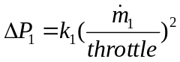 (Pa) (Eq. 9)

ΔP₁ and all the pressures are in Pascals. Throttle is 1 when the opening is its full 2-inch pipe size and 0 when it is fully closed. The parameter k₁ is calculated from theory to be 0.224 for that pipe size.

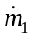 is the primary air flow rate in grams/sec.

ΔP₂ is the frictional pressure drop through the unburned fuel. This is not the true pressure drop, because the true pressure drop also includes a buoyancy factor. Here, the buoyancy factor is included in Eq. 8. The formula for ΔP₂ is:

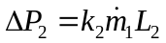 (Eq. 10)

This equation assumes that Darcy flow exists in the fuel bed, that is, laminar flow between the fuel pellets, with pressure drop per unit distance being proportional to fluid velocity. This is probably a good assumption with the pelletized fuel and fuels which come in smaller pieces, but may not be a good assumption with fuel with larger air gaps between the fuel pieces (vertical sticks, large cubes of fuel, etc.)

ΔP₃ is given by a similar formula:

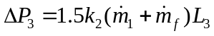 (Eq. 11)

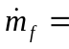 fuel release rate (pyrolysis rate)

Again, Darcy flow is assumed to exist, in which case the pressure drop per unit distance will be proportional to the total gas flow, which is greater than in the unburned fuel zone.

The number 1.5 in Eq. 11 was a parameter adjusted to give results that agree with experimental observations. In particular, it was noted that during the burning process the size of the flame would slowly go down (see Fig. 8) until the last portion of fuel was burned. Preliminary use of the model showed that if the number 1.5 were replaced by a larger number, the model would predict a greatly decreasing flame size. As burning progresses L₂ gets smaller and L₃ gets larger, causing higher pressure drop and less flow through the packed bed. In theory, the 1.5 number might be expected to be larger, since the gases flowing through the char layer will be very hot and thus higher in viscosity than the gas flowing through the unburned fuel zone. Also the gas will have lower density, and thus higher speed for a given mass flow. However, since the physical principles determining the pressure drop through the packed fuel bed were not well understood, adjustable parameters were used rather than ones that were more theoretically correct.

It was assumed that the sum of L₂ and L₃ was constant and equal to the total depth of the fuel bed at the start of the test. In reality, the fuel will settle somewhat, the amount depending on the fuel, so the sum of L₂ and L₃ will decrease somewhat during the test.

ΔP₄ is the pressure drop through the concentrator plate given by:

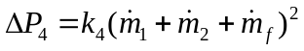 (Eq. 12)

where:

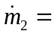the flow of secondary air.
The parameter k₄ is given by 0.18, which is its theoretical value based on pipe flow.

ΔP₅ is the pressure difference across the secondary air inlet. This pressure drop is what determines the secondary airflow.

The secondary airflow is given by:

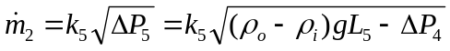 (Eq. 13)

The parameter k₅ can be estimated from orifice flow considerations, but must be adjusted to fit experimental results since the discharge coefficient for the ring gap is not well known, and is not the same as for the more familiar pipe orifice situation. A value of k₅ was selected that gave reasonable results, and was not too different that the theoretical number using an orifice discharge coefficient appropriate to pipe flow.

All of the k factors were selected and “tuned” for the stove under “normal” conditions, those being open throttle, hardwood pellets used as fuel, 3/16 inch gap for secondary air, 6-inch diameter pipe with a 3-inch hole in the concentrator plate, 8 inches original depth of the fuel, but with half of it unburned and half of it as char. Thus L₂ and L₃ would each be 4 inches (0.1 meters). For these conditions the gas temperature and the temperature in the char zone are around 6-700° C, the fuel pyrolysis rate is about 0.36 g/sec, the primary air is 0.47 g/sec, and the secondary air is about 1.7 g/sec. The total air to fuel ratio (AFR) is about 6, based on the sum of the primary and secondary air flow. The parameter k₂ was set at 15 and k₅ was set at 1.4

For a different size stove all of the k parameters except k₂ could probably be estimated from theory. For a different fuel k₂ would have to be altered. For a given shape of fuel pellet, k₂ will be inversely proportional to the dimension of the pellet squared. For example, if the pellets are cylinders with the length of the cylinder being a fixed proportion of the diameter of the cylinder, k₂ would be inversely proportional to the diameter of the cylinder squared.

The first thing that was done with the model was to investigate the following situation. If the fuel bed is made of small pieces and there is an air void within the bed, particles of fuel can be heard to drop down through the air void, and if these particles are hot they can ignite the fuel bed all around the air void rather than having the pyrolysis move steadily from the top of the fuel bed to the bottom. The fuel pyrolysis rate is probably proportional to the amount of fuel that is being freshly exposed to heat, and when a pellet drops through an air void, there can be a rapid increase in the amount of fuel exposed to heat. (This is similar to an observation by Larry Winiarski that when feeding wood into a rocket stove by hand, it’s not the mass of wood being fed into the stove that determines the fire size, it’s the surface area of the wood.) When this happens the stove usually starts producing more combustible gas than there is oxygen to burn it, and the stove starts putting out a lot of smoke. This situation lasts for a few minutes, then the stove settles itself down to more normal operation.
To investigate this, the pyrolysis rate, m dot f, was forced to vary through a range of values, and the primary and secondary air flows were allowed to vary based on pressure drop. This was with L₂ and L₃ both equal to 4 inches (0.1 meter). The results are in Fig. 10.

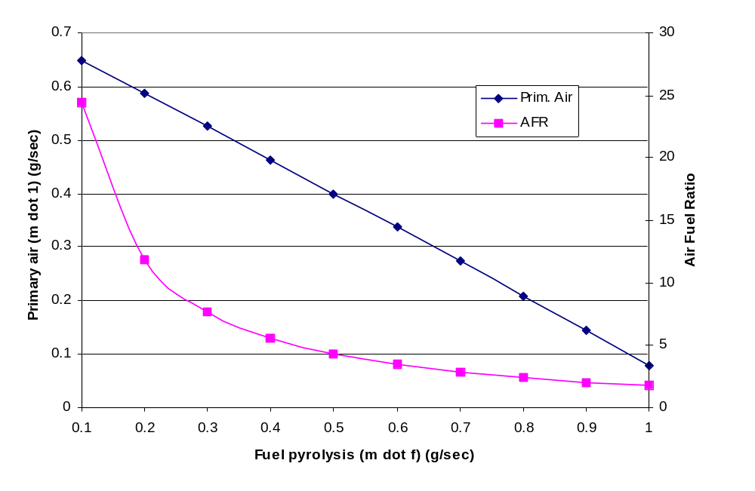
Figure 10: Primary air flow and overall air to fuel ratio as pyrolysis rate varies.

We see that the primary air decreases to nearly nothing as the pyrolysis rate increases. Basically there’s only so much buoyancy pressure available to push gas through the fuel bed, and the fuel gases displace the primary air flowing through the fuel bed. In the actual stove, this reduction in primary air, over the course of a few minutes, reduces the pyrolysis rate which is why the stove eventually goes back to normal operation.

In the short term however, the air to fuel ratio decreases greatly from its normal value of about 6 when m dot f is its normal value of about 0.36. This accounts for the large amount of smoke.

The effects of throttling the stove were also studied. Figure 11 below shows the effects of the throttle setting. For this graph it was assumed that the fuel pyrolysis rate was approximately proportional to the primary air, in the ratio of 0.47 to 0.36. This comes from the experiments with fixed primary air flow in which this was the ratio under “normal” operating conditions.

It can be seen that the throttle has little effect on fuel pyrolysis until the throttle is fairly closed. This agrees with observations of the stove. This is because at open throttle the stove opening produces very little pressure drop (ΔP₁) compared to the other pressure drops in the system. Only when the throttle is significantly closed does the throttling pressure drop increase to the 1 Pa range or more and become significant. At this point the primary air flow decreases significantly and pyrolysis rate drops proportionally (so it was assumed) while the secondary air stayed fairly constant. The flame size drops, and the air to fuel ratio increases greatly, resulting in cool outlet temperatures.
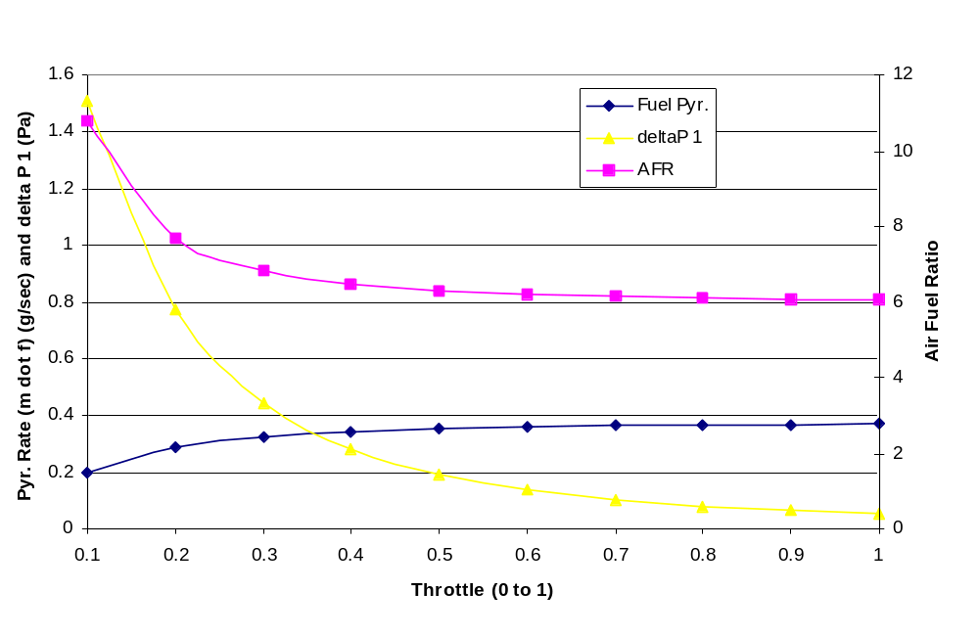Figure 11: The effects of the throttle setting.

This also shows that the inlet to the stove could be smaller than the current 2-inch diameter pipe.

The ultimate objective of the model was that once the basic model was developed and verified, variations of the stove could be modeled in a similar fashion, attempting to find a stove design that would have a more constant air to fuel ratio under a wider range of conditions. In other words, a stove design was sought that would maintain a more constant air to fuel ratio as the fuel release rate, throttle opening, and other factors were varied to eliminate the problem of temporary smoking as described above, and to keep the outlet temperature more constant. None of the alternative designs studied to date were significantly better than the basic stove, and are not described here.

Conclusions

When using the proper fuel the stove has many good characteristics including high output temperatures, easy controllability, high power, and clean burning. However, the stove appears to be very fuel sensitive. While a range of fuels can be used, the range is not wide, and the packing of the fuel into the fuel canister can be an issue. If these factors are not right the secondary flame can extinguish, or other problems can develop, creating a large amount of white smoke and hydrocarbons. Other conditions can lead to extinction of the secondary flame.

Acknowledgements

The author acknowledges Katherine Kinstedt, an Ohio State University undergraduate, for help with some of the experiments and with the graphics of the report. Nordica MacCarty assisted with the hood test of the stove. As always, the author acknowledges his employer, SEA, Ltd. for generously providing time and resources to perform this investigation.

References

Berick, Alan, Heat Losses In a Cooking Pot While Simmering [Where Does All That Energy Go?], unpublished report, 2006.

Bhattacharya, S.C., Albina, D.O., and Abdul Salam, P., 2002, Emission factor of wood and charcoal-fire cookstoves, Biomass and Bioenergy, 23, Elsevier Science Ltd., pp. 453-469.

Bond, Tami, Venkararaman, Chandra, and Masera, Oman, Global atmospheric impacts of residential fuels, Energy for Sustainable Development, Vol. VIII, No. 3, September, 2004, pp. 54-66.

Simpson, William T., 1998, Equilibrium Moisture Content of Wood in Outdoor Locations in the United States and Worldwide, Forest Products Laboratory Research Note FPL-RN-0268, US Department of Agriculture, Forest Service.

Presented at the ETHOS 2007 Conference, Kirkland, Washington, January 27, 2007, Engineers in Technical and Humanitarian Opportunities of Service http://www.vrac.iastate.edu/ethos
Paul Anderson, psanders@ilstu.edu
Aprovecho Research Center, Cottage Grove, Oregon, http://www.aprovecho.org/

